http://127.0.0.1:5500/index.html

Session setting🡪uncheck Enable secure and persistent browser

To add current folder pic in the img:<img src=”./picname”/>

Inline tags:<Span><Strong>

CSS:

Id=>#Idname(applied for single tag)

Class=>.classname(applicable for multiple tags)

Inline css:<div style=”property:value;another property:value”>

External css:create css file and embed in head tag =><link rel="styleSheet" href="./myCss.css">

We don’t have id # selector in lwc

Padding = invisible space outside content

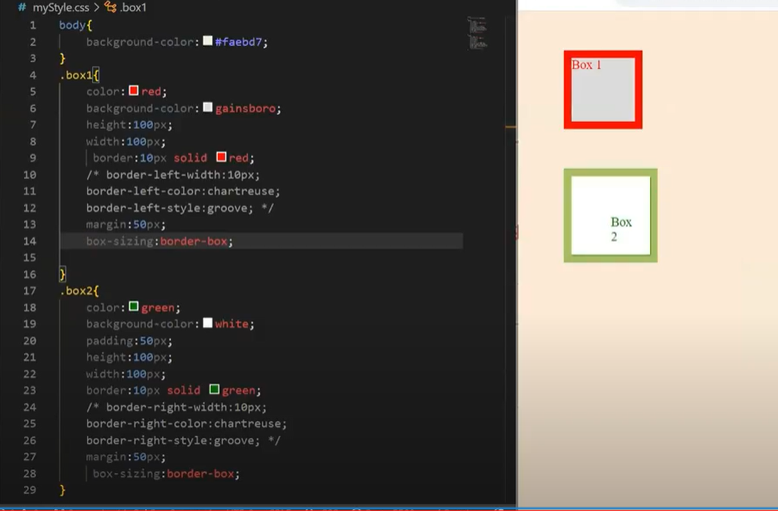

For updating vs code:sfdx update

CSS Box model:  
Content ,padding,border,margin

Border – radius ->for circle

SLDS:Living,open source,enterprise,accessible,platform agnostic(can be used in other platform)

Principles of slds:  
Clarity  
Efficiency  
Consistency  
Beauty

Padding ->invisible space around content

Padding🡪slds-p-around_large  
Border🡪slds-border_bottom  
Margin🡪slds-m-around_small

Alignment: align the components🡪if centre🡪slds-align_absolute-center

Text🡪capital letter🡪slds-text-title_caps

Display density:  
Two types:  
 comfy(Default)🡪will display the component with good spacing  
 Compact🡪will display the component with less spacing when compared to comfy

To make the component flexible for the display density :Use ‘var’ word  
Ex:slds-var-m-around medium

Grid Model:is divided into 12 columns🡪slds-grid

Column🡪slds-col

Slds-gutters:add padding to the slds-grid

Slds-size:To assign a size for the div🡪slds-size_2-of-6

Slds-grid_align center🡪will align the grids to the center

SLDS-WRAP assigned in slds-grid🡪to assign if the content is not fit within the grid should move to next line

Device agnostic:component view for multiple devices

**SLDS Styling Hooks**:

If we want to use the css custom properties into the component,override the std styles with custom styles

Naming Convention:--slds-c-button-brand-color-background

Customize entire dom::host  
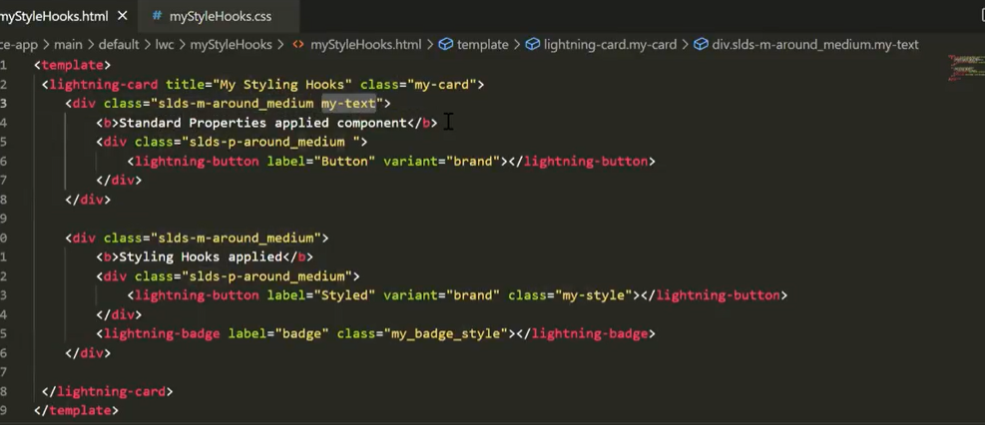

JavaScript:

Variables:  
Name of the variables 🡪identifiers 🡪var a=10🡪a

To add js file to html:<script src=”script.js”></script>

Var:  
 Re declaration🡪var a=100,var a=200  
 Updated(Re assignment)  
 Global Scope  
 Function Scope  
 Not a block level scope

For function scope:

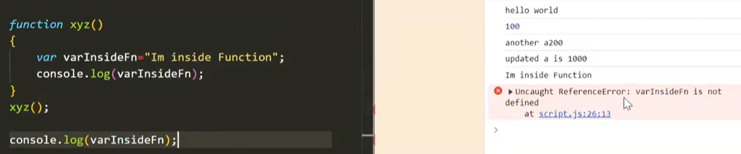

Let:

Updated(Re assignment)  
 Block Scope  
 Function Scope  
 Global Scope  
 No redeclaration

Const:  
 Block Scope  
 Function Scope  
 Global Scope  
 No redeclaration  
 No Updation(Re assignment)  
 Read Only

Data types in LWC:  
Js is a dynamic datatype language  
10,10.5 type of returns number  
Types:  
Number🡪Integer,float,Decimal  
String🡪double quotes/single quotes  
Boolean🡪True/False  
BigInt🡪store big integer values with arbitrary precision,const=678n,should finish with n.  
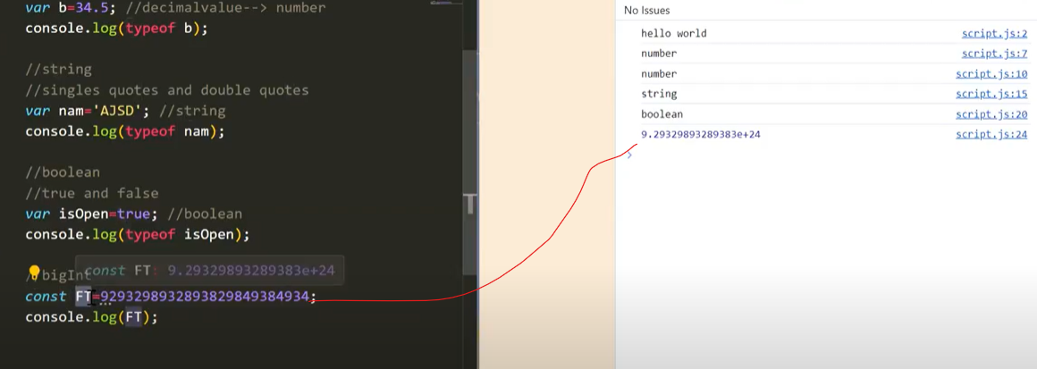

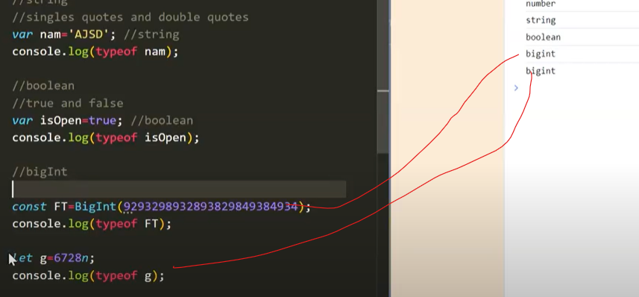

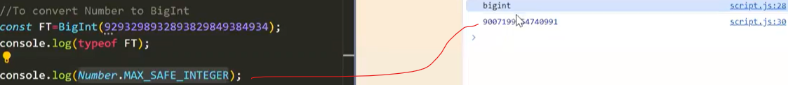

Object🡪stores in key value pair  
undefined🡪if var is declared and no value is been assigned,oly declared and not initialized  
Null🡪If a variable is explicitly assigned as null   
Symbol🡪Allows creating a unique identifier  
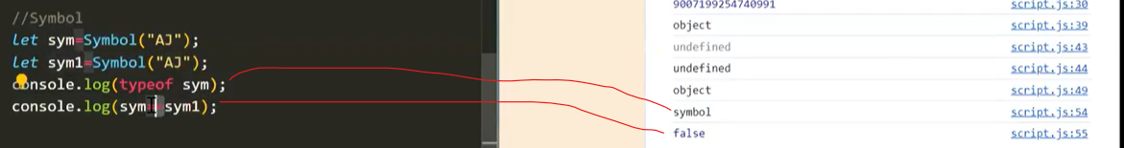

Above 8 datatype is primitive.  
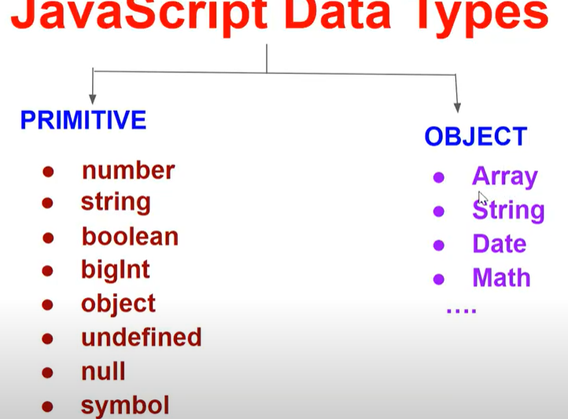

Operators:

==,!=🡪Compares value  
===,!==🡪compares value and its datatype

NULL Vs Undefined:  
typeof NULL🡪Object  
typeof Undefined🡪undefined  
undefined==null🡪true  
undefined===null🡪false  
Best practice:  
record=null  
not good:  
record=undefined

Functions in JS:  
Regular Expression  
Function Expression  
Named Function  
Callback function  
Arrow function  
<https://docs.google.com/document/d/16cgWvzZs9Wh76cyZJQxC2BpuG8hYxMW1/edit>

Callback function:  
When we are passing a function as parameter to another function  
Most built in js functions will be callback fn  
Higher order function and callback function  
function A(function B){  
}  
function A🡪Higher order function  
function B🡪Callback function  
To get the function name🡪fn.name  
Reusable and interconnect  
Abstraction  
To get an emoji🡪win+.  
<https://docs.google.com/document/d/1dZZXA8gN1xRc_-LKvTesQYM09Pgmgehv/edit>

Arrow function:  
Special form of function expression  
More structured and readable  
Mostly used in LWC

Advanced:Bind this value in the code context  
Const print=()=>console.log(‘AJSD’);

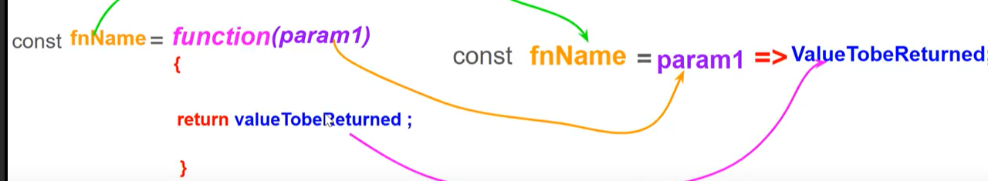

Don’t need to provide return statement if there is only one statement.  
<https://docs.google.com/document/d/1LMpbGtIC6bbsDq7lQ32lpCHmVzOFMkoH/edit>

String Interpolation:  
`${}`

Strict Mode:  
Secure JS Code  
Avoid accidental error and show us visible error in the console  
Without strict mode will not show what is wrong in code  
“use strict”;🡪should be the first statement in the code

Variable Hoisting:  
If we use var variable before it is declared🡪Undefined(Hoisting)  
If we use let variable before it is declared🡪Reference error :cannot access before initialization(not hoisted)  
If we use const variable before it is declared🡪Reference error :cannot access before initialization(not hoisted)

Function hoisting:  
Function Declaration🡪Hoisted  
Function Expression🡪 Reference error :cannot access before initialization(not hoisted)  
Arrow Function🡪 Reference error :cannot access before initialization(not hoisted)

If we use var in the func expressions and arrow functions🡪Typeerror:not a function

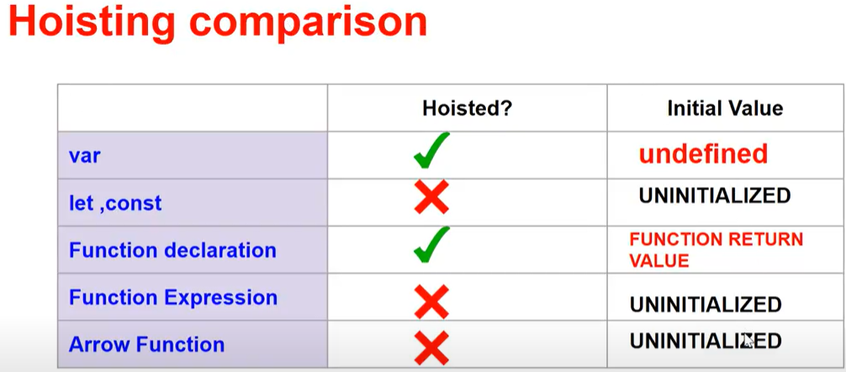

Switch-case-default:

Basics of array:  
arrName.length

Array methods:  
push🡪arrName.push(element1,element 2,..) 🡪add it in the end of the array🡪return length of newly modified array  
pop🡪 arrName.pop()🡪remove the element at end of the array🡪return the removed element  
shift🡪arrName.shift()🡪remove the element at start of the array🡪return the removed element  
Unshift🡪 arrName.Unshift(element1,element 2,..))🡪add it in the element at start of the array🡪 return length of newly modified array  
indexOf🡪arrName.indexof(element)🡪gets the index of the element🡪If we give the element that is not present in the array🡪returns -1  
Sort string🡪arrName.sort()🡪sort based on string array🡪sort based on UTF 15 code unit🡪cannot sort numbers only strings  
sort number🡪arrName.sort(function(a,b)  
 {return a-b};)

Or arrName.sort((a,b)=>a-b)

Iteration:  
for(let i=0;i<=10;i++)  
for..Of🡪for(variable of array){}  
for..in🡪for(variable in array/Object){}🡪variable will be index  
for Each🡪array.forEach(callbackfn,this arg)  
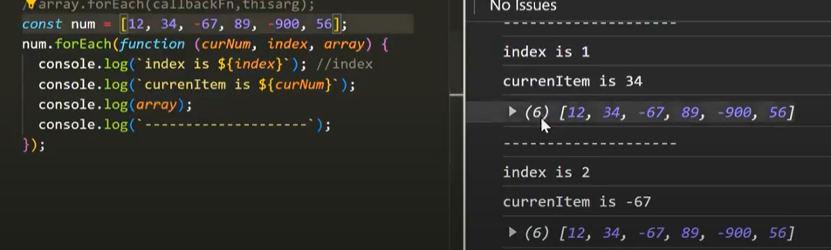

We cannot break/continue statement in for each loop  
We can create an arrow function also

Do…while🡪  
While🡪

Array methods:  
Every🡪array.every(callbackfn,thisArg)🡪tests whether all elements in an array pass the given condition,if all satisfies the condition it returns truel else false  
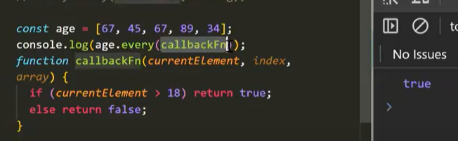  
Using Arrow function:  
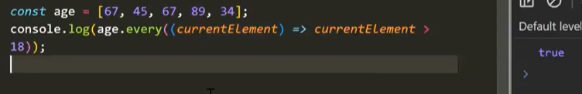

Some🡪 array.some(callbackfn,thisArg)🡪tests whether atleast one elements in an array pass the given condition,if all satisfies the condition it returns true else false

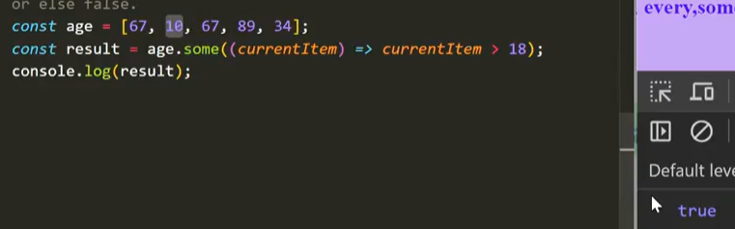

Filter🡪 array.filter(callbackfn,thisArg)🡪returns new array by filtering all values that satisfies the condition

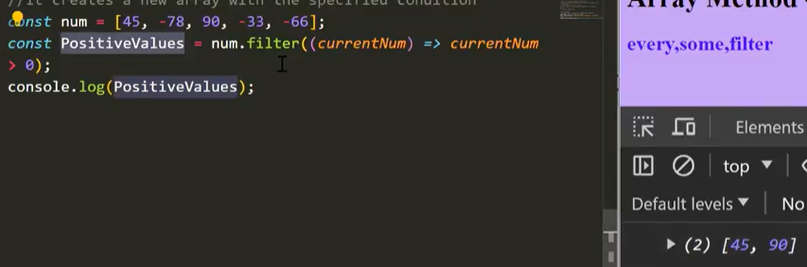  
Reduce🡪 array.filter(callbackfn,initial value)🡪If u want to transform the value into a single value  
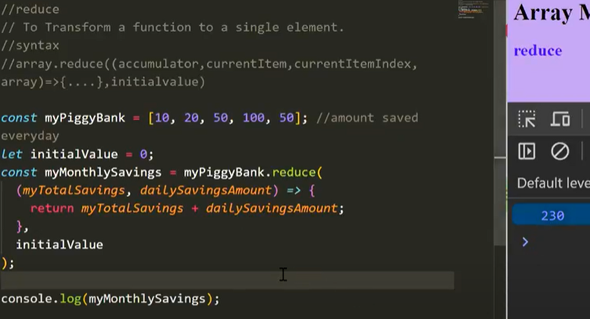

Accumulator holds result from previous value  
At first its value is initial value  
if no initial value it takes 0th intdex value  
If an array is empty and initial value is 0 then it provides typeerror

Array Concat:  
array.concat()🡪copying method🡪copes to another new array  
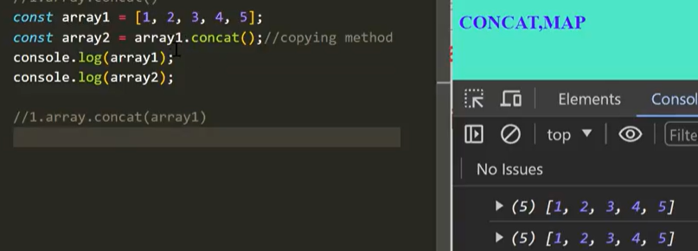  
array.concat(array 2)  
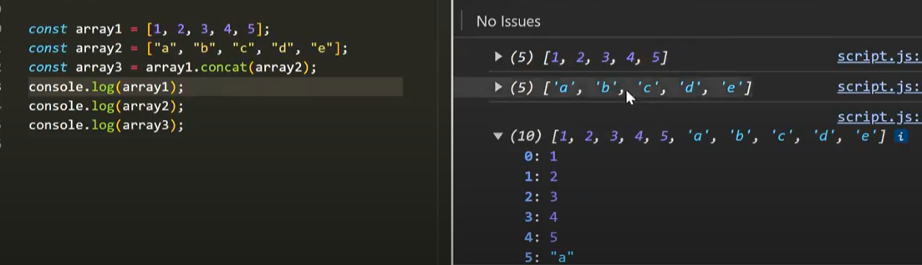  
array.concat(array 2,array 3)  
It returns new array but does not change the original array

Map: array.filter(callbackfn,thisArg)🡪creates a new array by applying a logic in the callback fn  
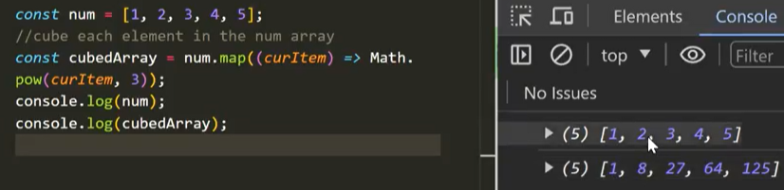

Slice:  
Slice();  
Slice(Start);  
Slice(Start,End);  
returns a shallow copy of a portion of an array into a new array,selected from start to end(does not include end)  
Original array remains the same  
arrayName.slice()🡪returns the whole array🡪copying method  
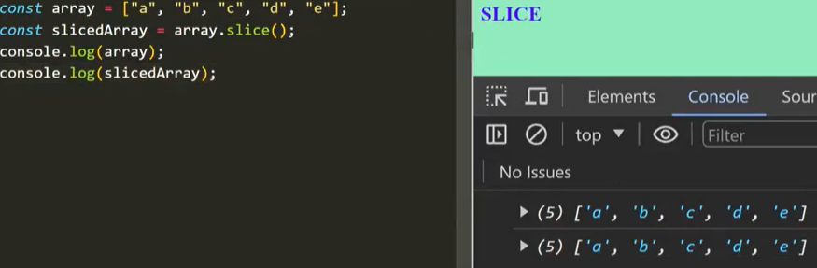

arrayName.slice(start)🡪starts from the given index value and upto end of the array

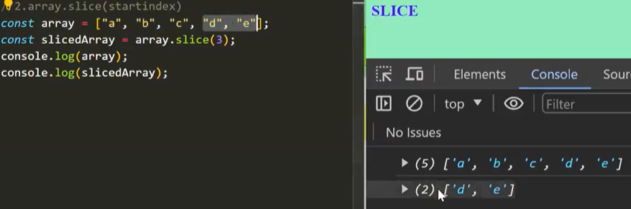

If we assign index as -1🡪it starts from the last element  
arrayName.slice(start,end)🡪ignores the end element

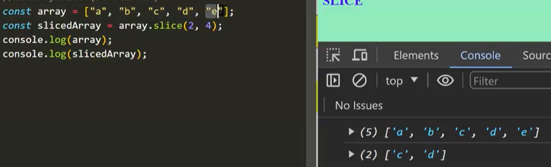

Splice:Change the contents of the original array by removing or adding an element  
splice(start);  
If only start index is given it removes the element from the start to end index in original array and returns the removed element in a new array  
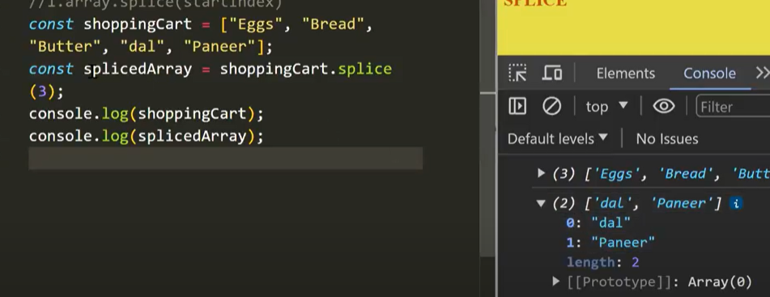  
splice(start,deletecount);  
it start deleting from the start index and number of elements from the deletecount  
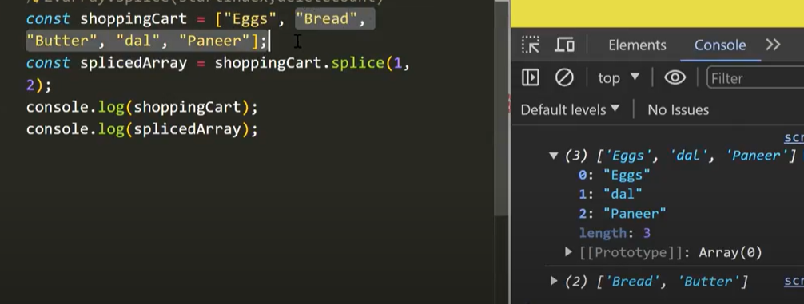

If deletecount>array.length🡪deletes till the end of an array  
splice(start,deletecount,item1);  
splice(start,deletecount, item1, item2….);  
item will be added in the start index  
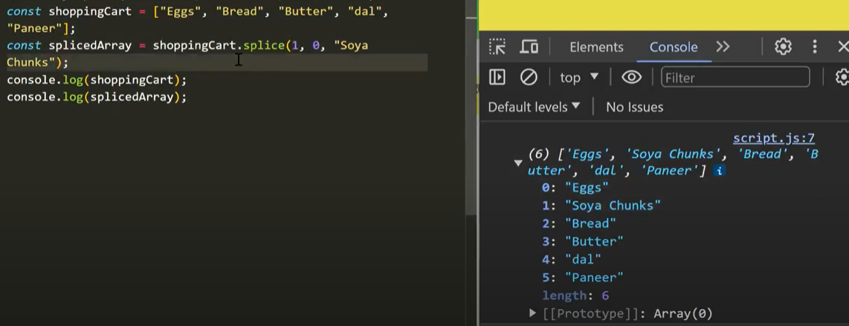

Replacement:

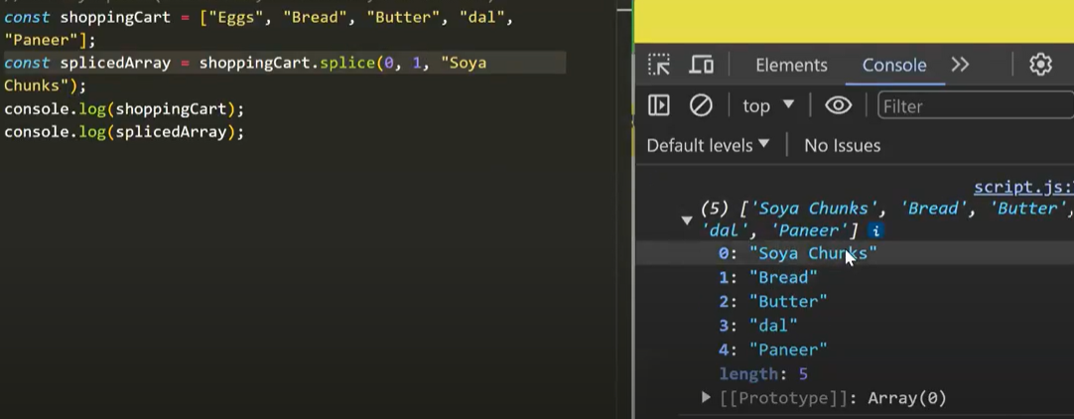

Array Destructuring:  
Extract values from a array and store them into a variable  
Unpacking the arrays  
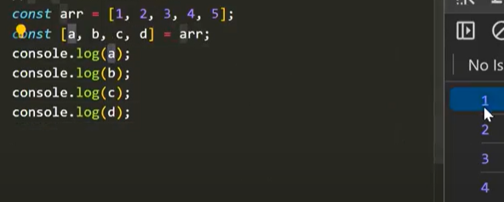

If we use ,, inbetween it skips and stores next variable  
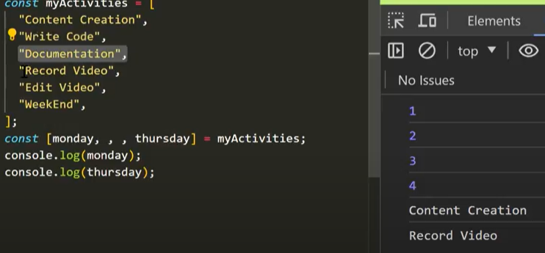

String Methods:  
includes🡪checks in the string and returns true/false🡪case sensitive  
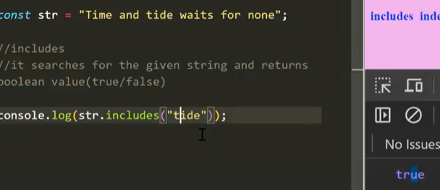

Str.includes(“word”,index)🡪starts checking from the index

indexOf🡪returns the index of the word(first occurrence)  
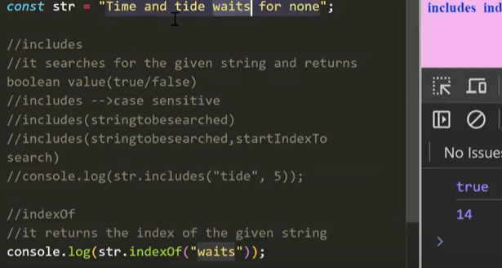

startsWith🡪returns true if the given string starts with the mentioned string 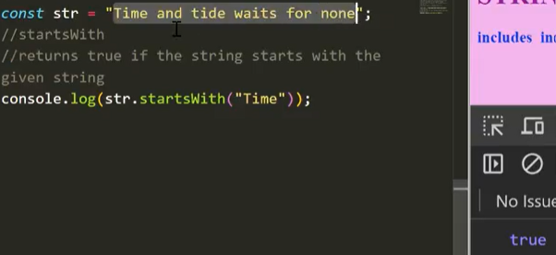

slice🡪returns a new string by cutting out from the original string by start and end indices.  
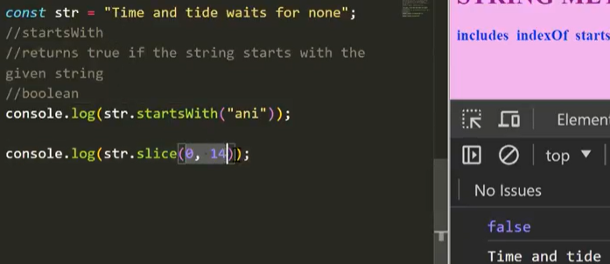

toLowerCase,toUpperCase:

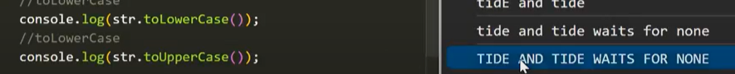

Trim:removes the extra spaces  
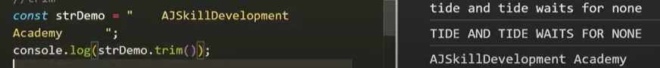

Spread operator:  **…**spread the iterable elements(array/string) or the properties of an object into another array/object  
convert the string into an list of array  
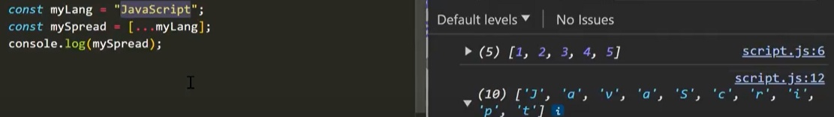  
concatenating an array  
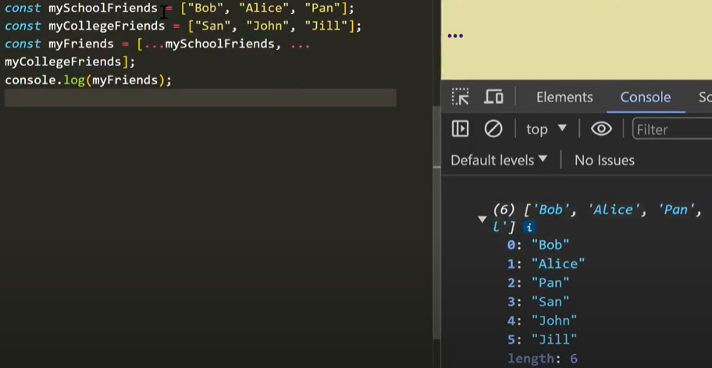  
adding elements to an array  
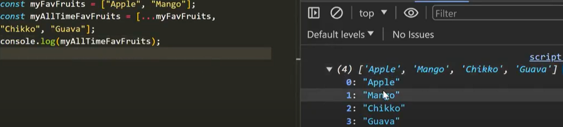  
copying an array  
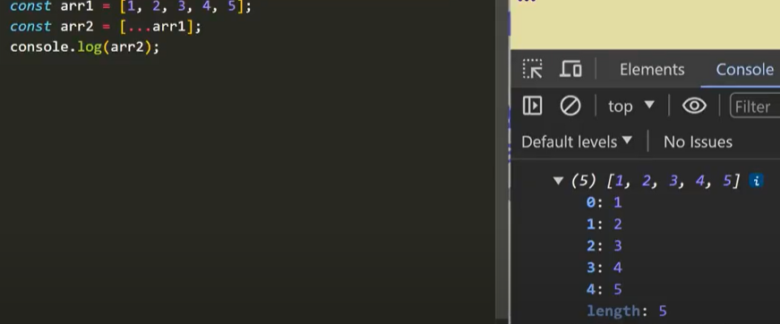

Rest Operator: **…**🡪opposite of spread operatorWhen we want to store some variables from an array to a separate array  
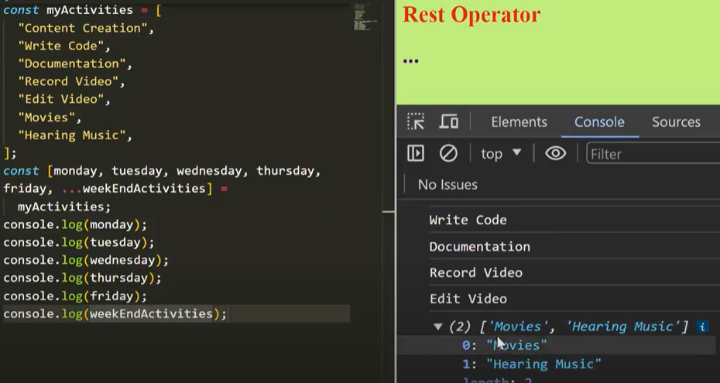

In a function:  
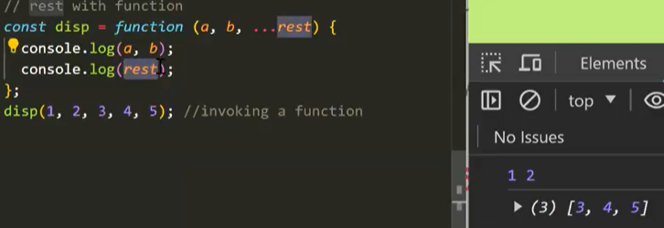  
Rest element must be a last element  
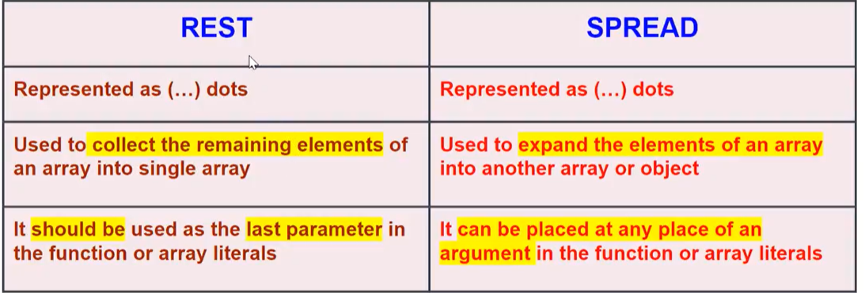

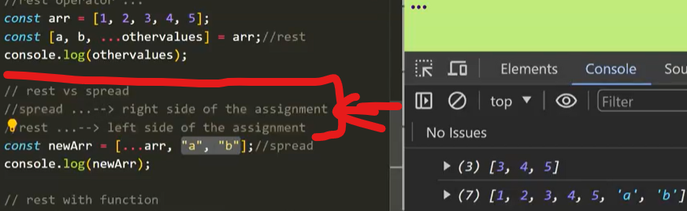

Objects in JS:Key-value pair,complex data type  
function inside object🡪methods or properties  
Access object values:  
**objectName.keyName;(Dot notation)  
objectName[“key”];(Bracket notation)🡪advanced mostly during integration(whenever key is inside double quotes we can go for this)**

Create an object:  
Object literal  
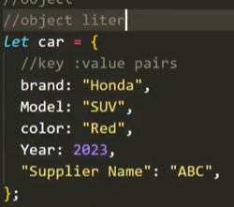  
Factory function  
object.create  
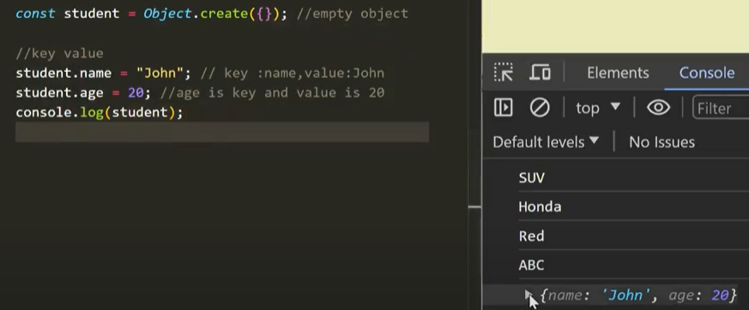  
**constructor function  
using class syntax(both will be seen later)**

Object.keys🡪return array of keys in the object  
Object.values🡪 return array of values in the object

Function inside object:  
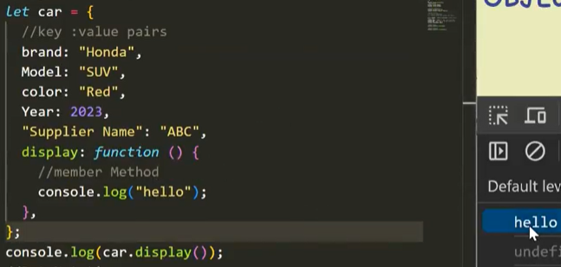

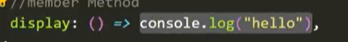

Factory functions:

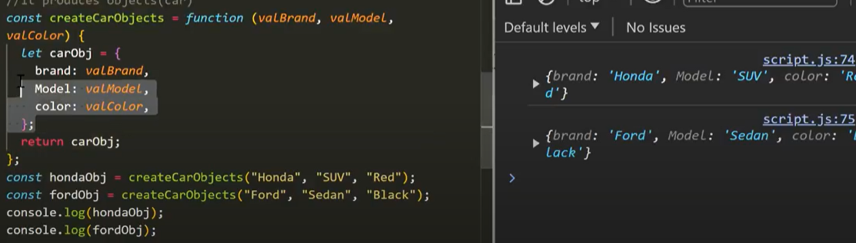

Object Destructuring:Should have the same key name  
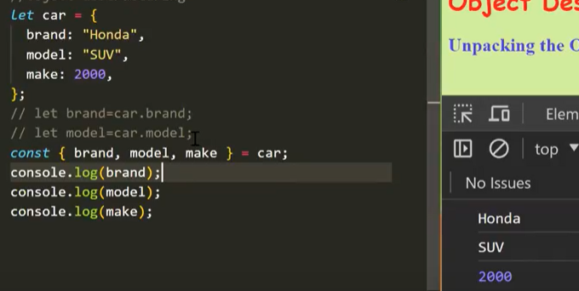

Shallow Copy:variables share the same memory reference when being copied  
Spread operator also shallow copy

Deep copy:copies the value and store in some other memory location  
forEach  
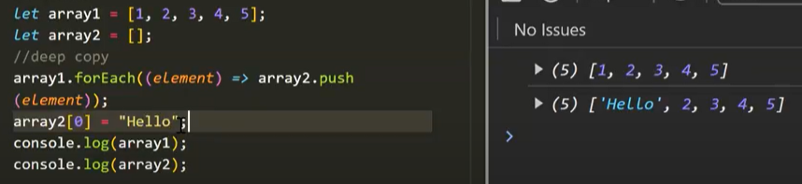

Structured Clone  
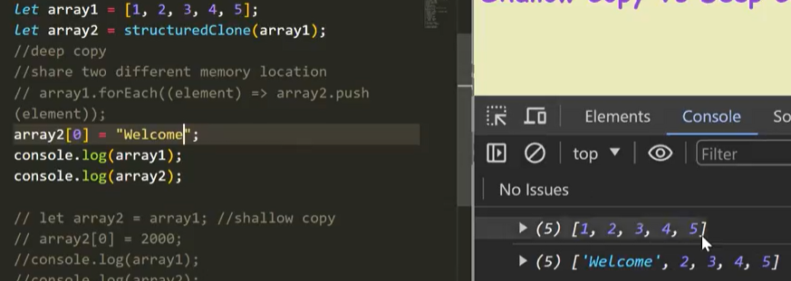  
Json.parse,Json.stringify:  
JSON🡪JavaScript object notation🡪lightweight data interchange format🡪easy for human to read and write and easy for machines to parse and generate  
We have to send in a string format thro Json.stringify to the server  
From server it process and send the information in the string format to the client where we can use json.parse to convert into object

To serialize the data and store in the database  
when we want to send the data into API  
To make a deep copy of an object or arrays  
To convert any datatype to string

When we use JSON.stringify converts an object to string  
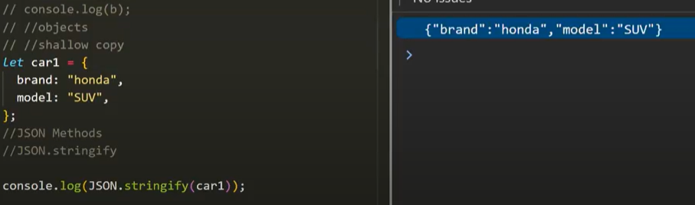

When we use JSOn.Parse converts the string to object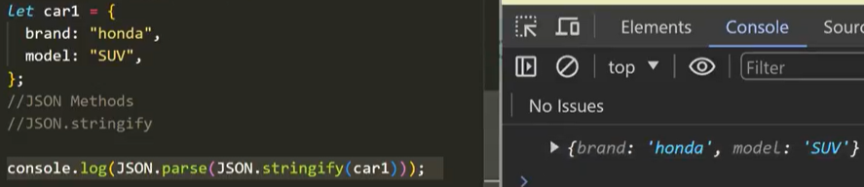

Deep Copy:using JSON Methods  
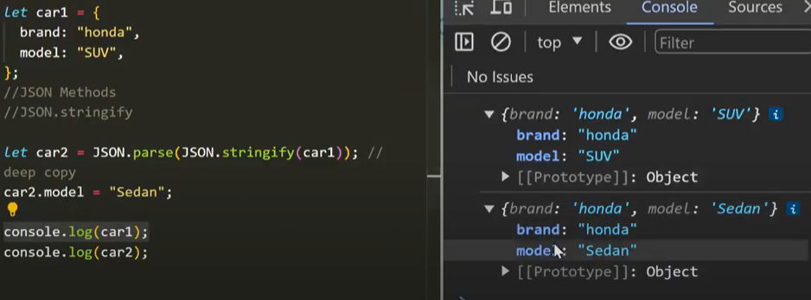

Third party utility library(Lodash)

Deep Copy Limitations:  
When we use a function or method inside an object it will not copied to the other array in deep copy  
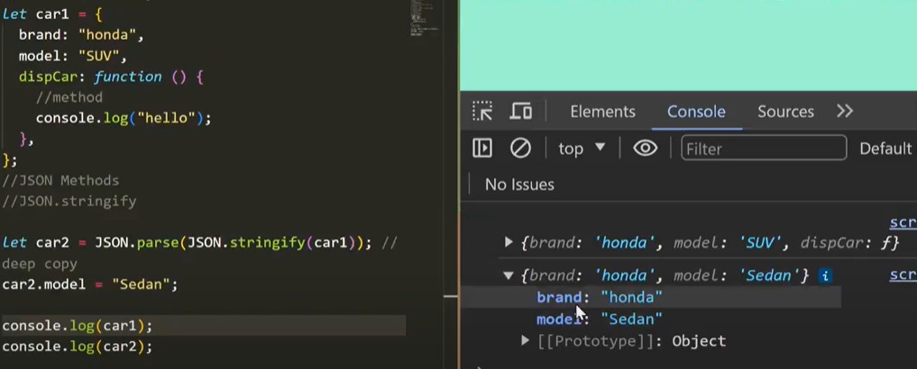

In shallow copy it copies the functions to the other array  
Shallow copy does not work for nested array Ex const arr=[1,2,[3,4]];

this Concept:  
this is a dynamic,value depends on the context where it is called  
if we call this globally it returns window object(window is a global object)  
changes value based on the owner(object)  
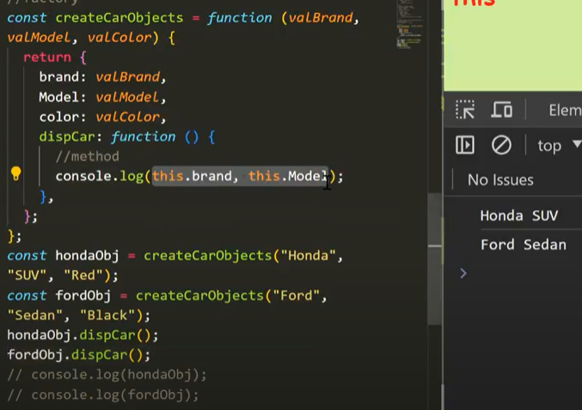  
When used with DOM events it points the event listener

this with arrow function:  
It doesn’t have its own this  
It borrows the surrounding scope or parent scope of this  
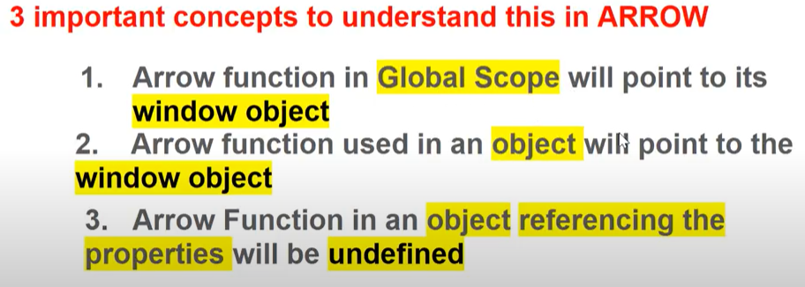

Arrow method with this keyword inside the objects  
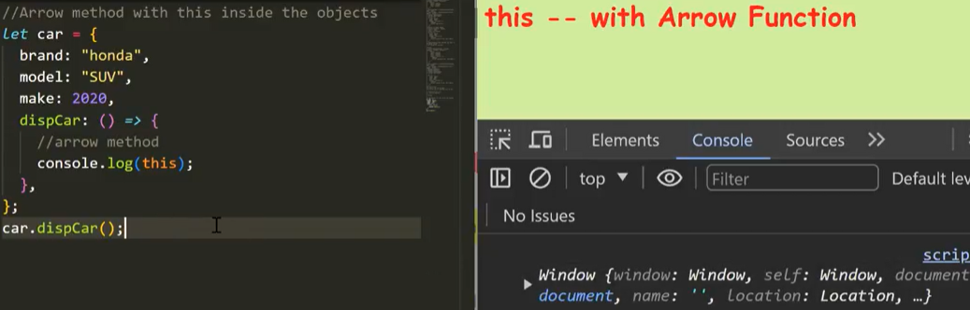

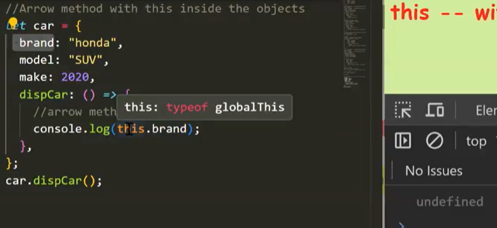

Don’t use arrow method inside an object  
Arrow function uses the “lexical this” means it uses this of its parent scope  
When we use a nested function inside an object inside function doesn’t have any scope on this  
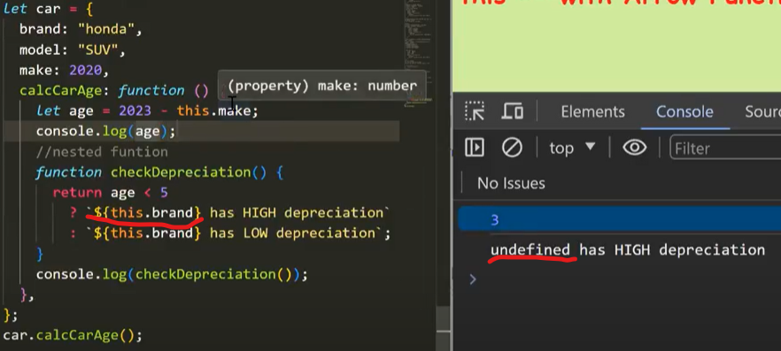  
Arrow function doesn’t borrow the scope from the object but borrows the scope from the parent function so to overcome above nested fn it uses arrow fn

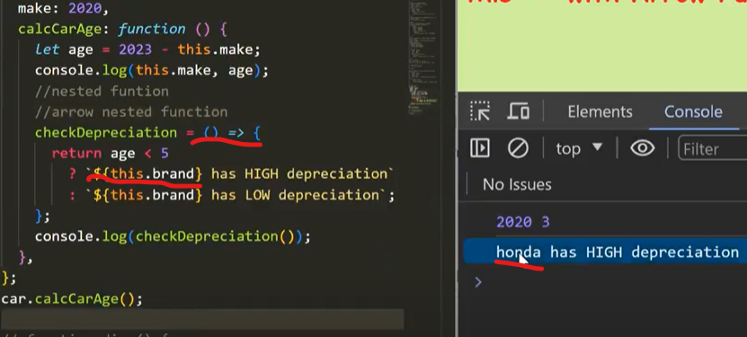

Promise:is an object  
Has success or failure callback function  
Represents the eventual completion of an asynchronous operation and its resulting value  
It returns a value at some point in future  
Has three states:  
 Pending(Initial State)  
 Fulfilled(Value)  
 Rejected(Error)

Two properties:  
 State  
 Result  
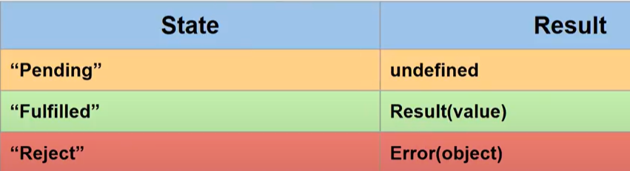  
Resolve,Reject🡪Executor  
To get the value of promise use then() method  
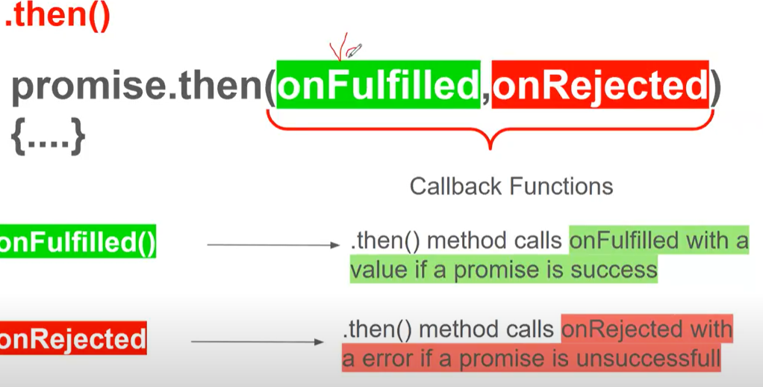

.catch():  
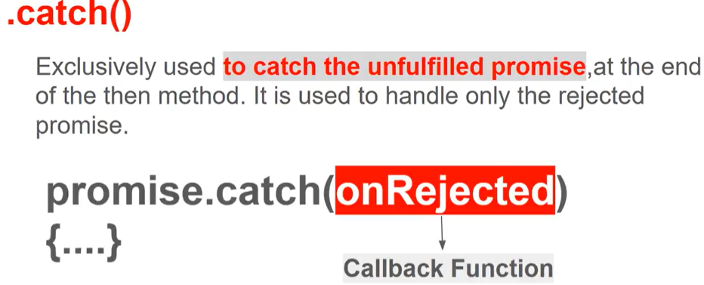

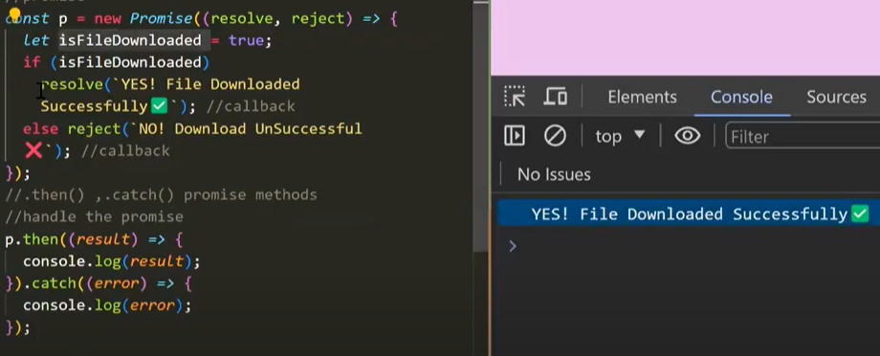

.finally():call this finally eventhough it has an result or error  
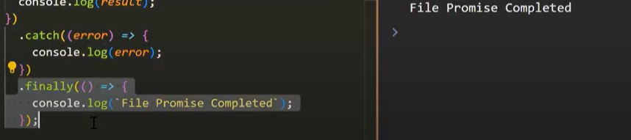

Promise.all():  
used to handle many asynchronous process at a time  
Promise.all static method takes an array of promises as input and returns a single Promise  
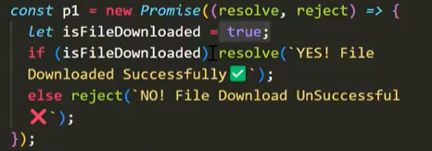  
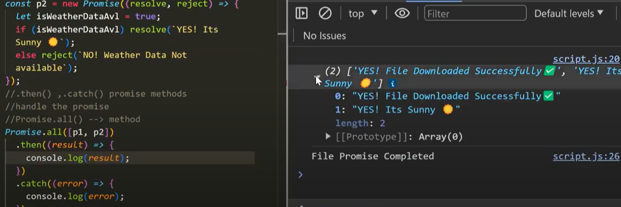

Stores the result of both promise in an array.  
If any promise gets any one reject callback then it displays only reject output doesn’t display the resolve output  
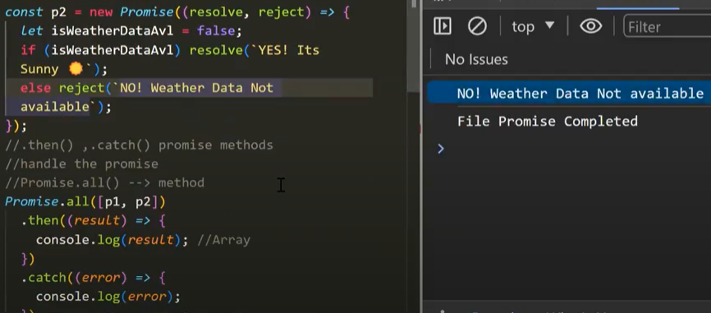

Displays the first rejected output.  
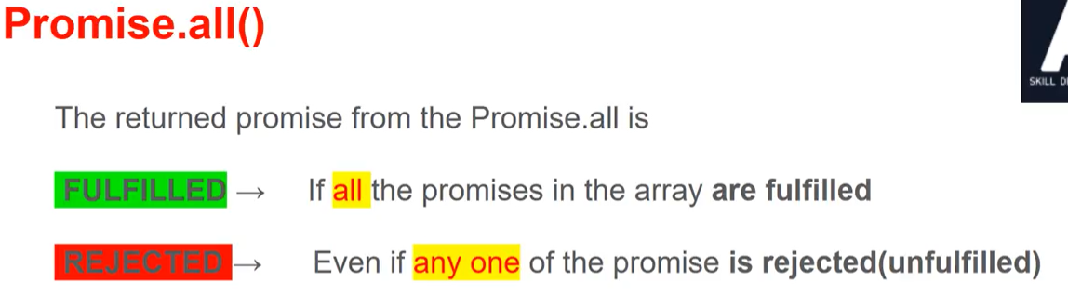

Promise.allSettled():  
will wait for all the promises to complete regardless of any rejection  
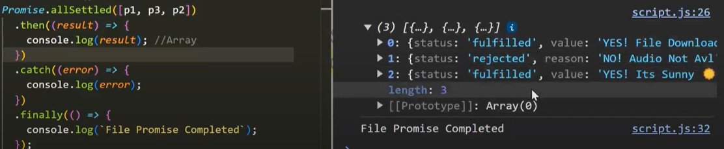

Promise.race():  
Static method takes an array of promises as input and returns a single promise(First settled promise either result or error)  
Returns a promise which settles first  
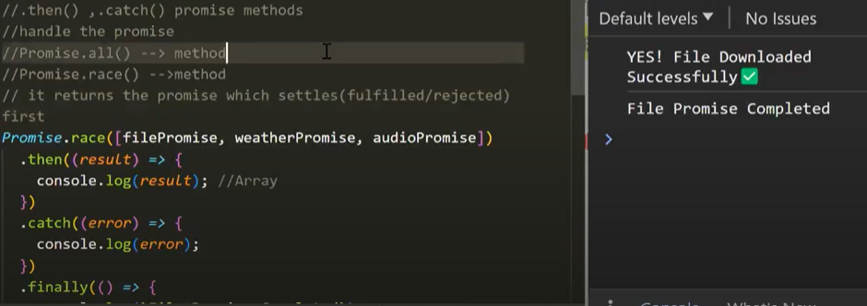

SetTimeOut:  
Calls a callback fn after specified milliseconds  
setTimeOut(callbackfn,delay){}  
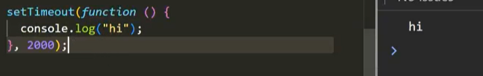

Using arrow function:  
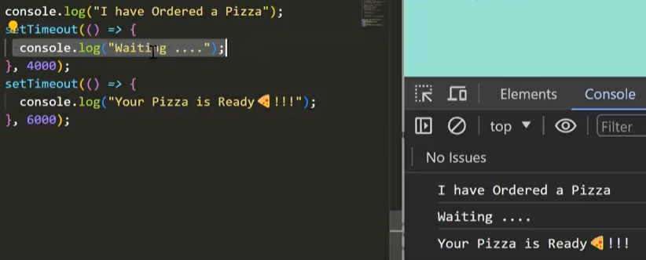

It returns the timerId  
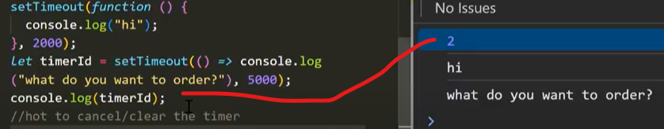

Clear the TimeOut:  
clearTimeOut(timerId);

SetInterval:  
Calls a function at specified intervals repeatedly with a fixed time delay  
setInterval(callback fn,delay)  
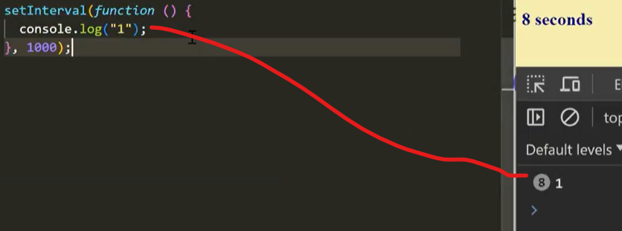  
It continues calling the function until the clearInterval() is called or the window is closed  
Returns the timerId

ClearInterval:  
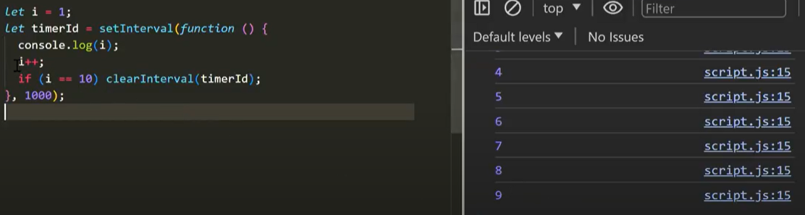

SetTimeOut vs SetInterval:  
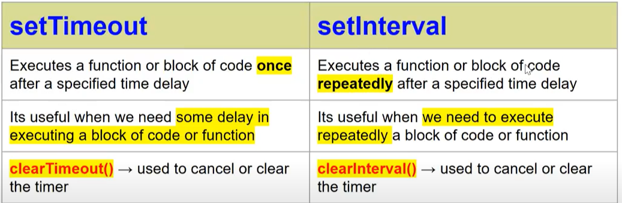

Class:Create an object from class syntax  
Blueprint/template to create object  
class className{  
 properties declaration;  
 constructor(value1,value2){  
 this.propertyName=value1;  
 ………  
 }  
 }  
Create instance of the class:  
const objName=new className(values….);

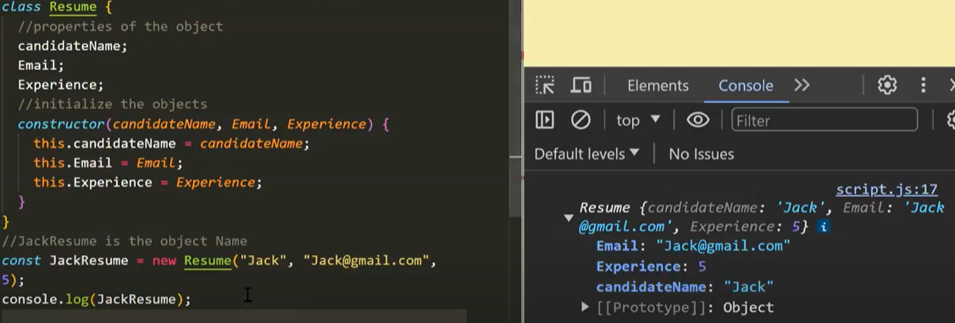  
we can create a method(function) inside a class(but should not use function keyword).  
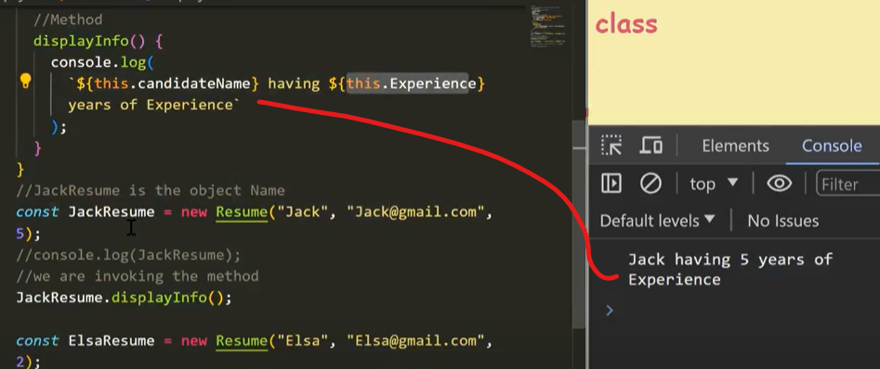

Events and Event listeners:  
Interactions that happen in a browser such as clicking on a button,etc  
onclick  
onchange  
onmouseover  
onmouseout

EventHandlers:things should be done when an event occurs in a page,will be written in javascript

QuerySelector and QuerySelectorAll:  
returns the first element in the document that matches the specified selector or group of selector   
document.querySelector(Selector);  
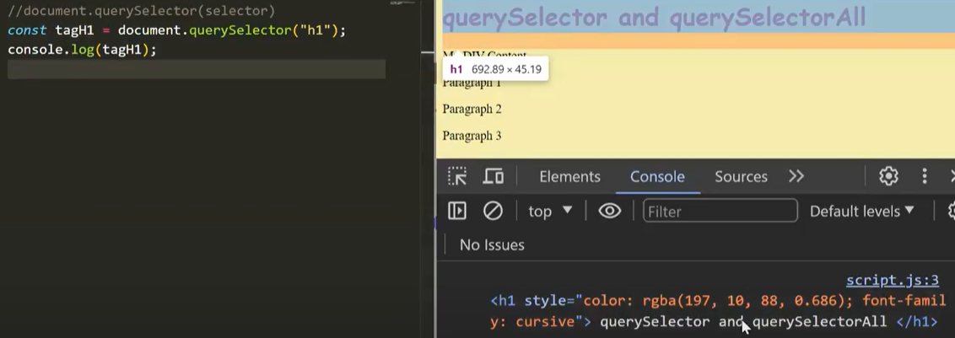  
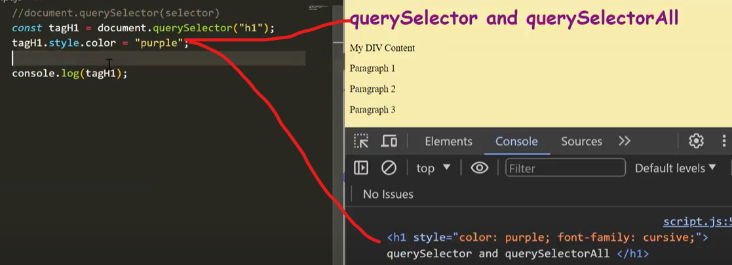

Properties that are useful to modify the HTML Tags:  
innerHTML:returns the tag and content of the html  
we can even change the tag and content of the html as below  
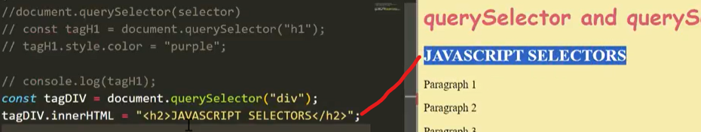  
innertext: we can change the content of the html as below  
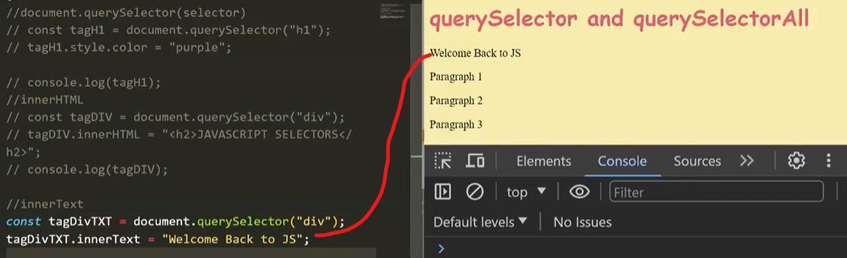

Node list:set of tags in html

QuerySelectorAll: returns all the element in the document that matches the specified selector or group of selector in the form of node list  
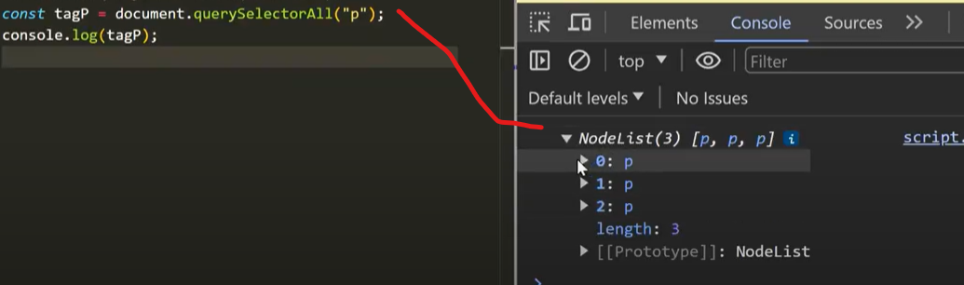  
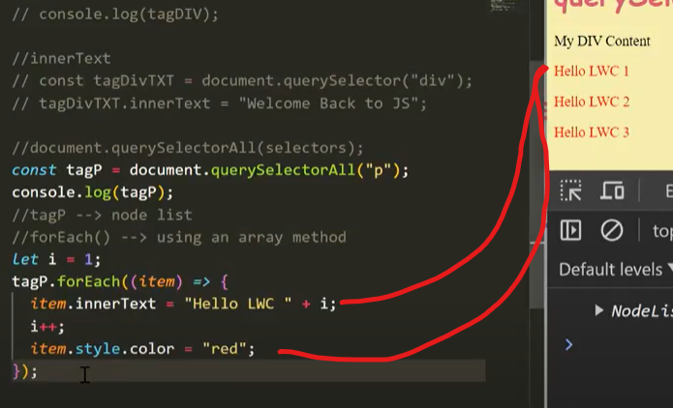  
Change the array from nodelist to array:Array.from(arrName);  
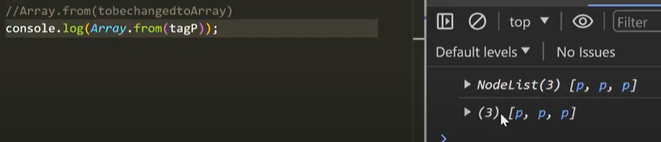  
using classname in queryselector:  
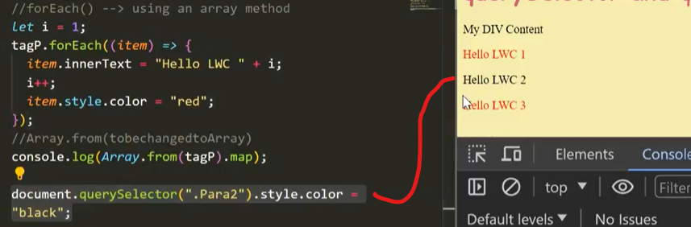  
  
Naming Conventions:  
camelCase:  
PascalCase:  
kebab-case:  
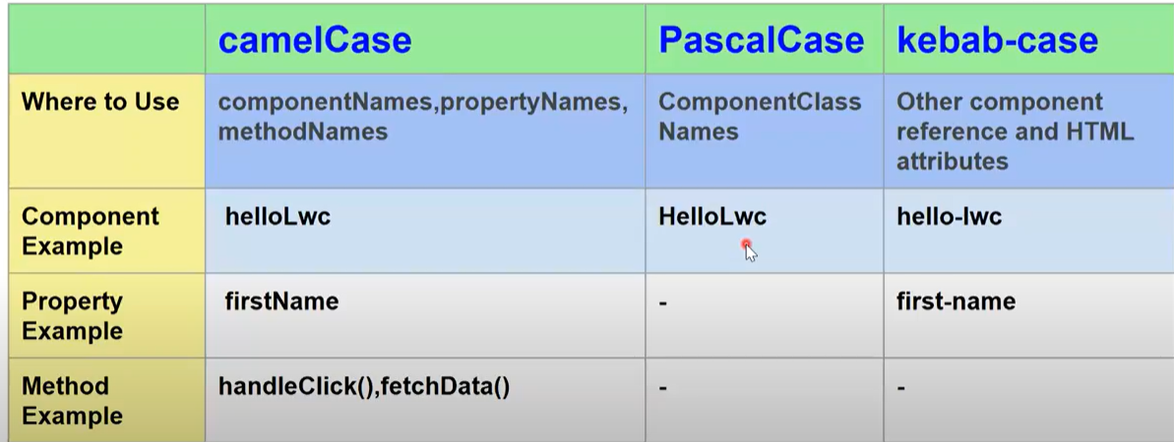

Files that can be added in a component bundle:css,svg(Scalar vector graph)  
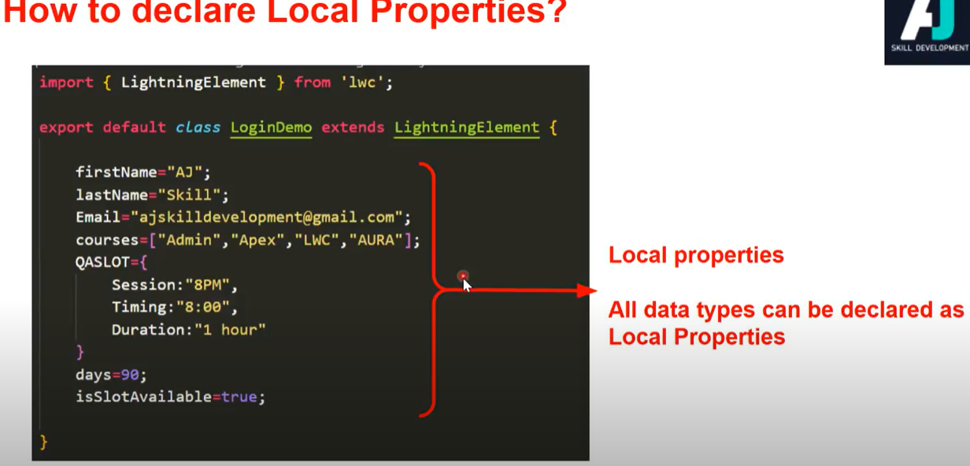

How to invoke method inJS:  
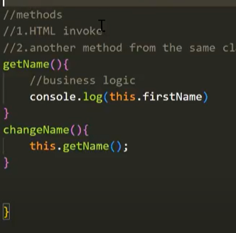

Databinding in CSS:  
One way databinding:  
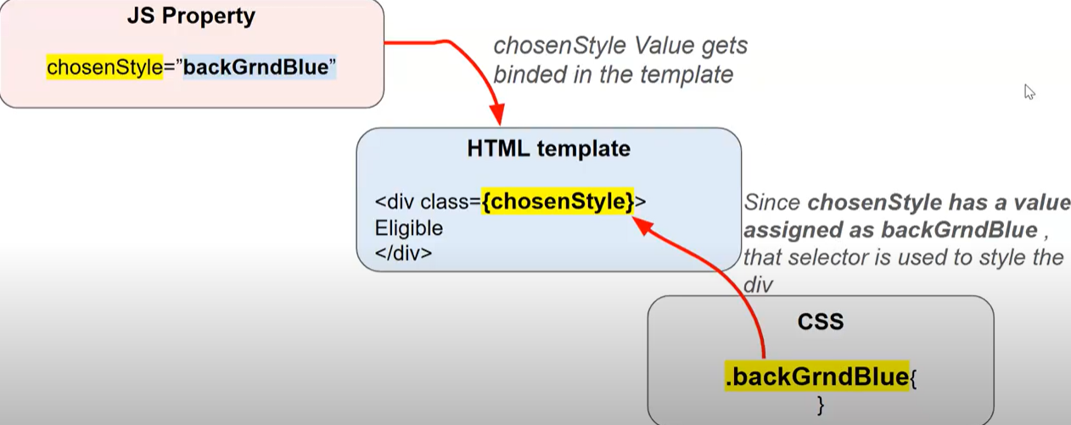

Two way databinding:

Getters:  
when we have to do computations before rendering the component  
Doent need to invoke will be automatically invoked and reactive   
get propertyName(){  
return expression;  
}

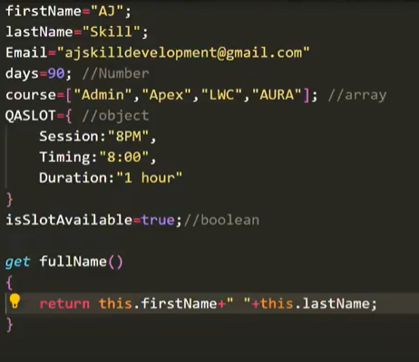

Reactivity:  
Primitive data types are naturally reactive  
Non primitive data types like object and arrays are not reactive  
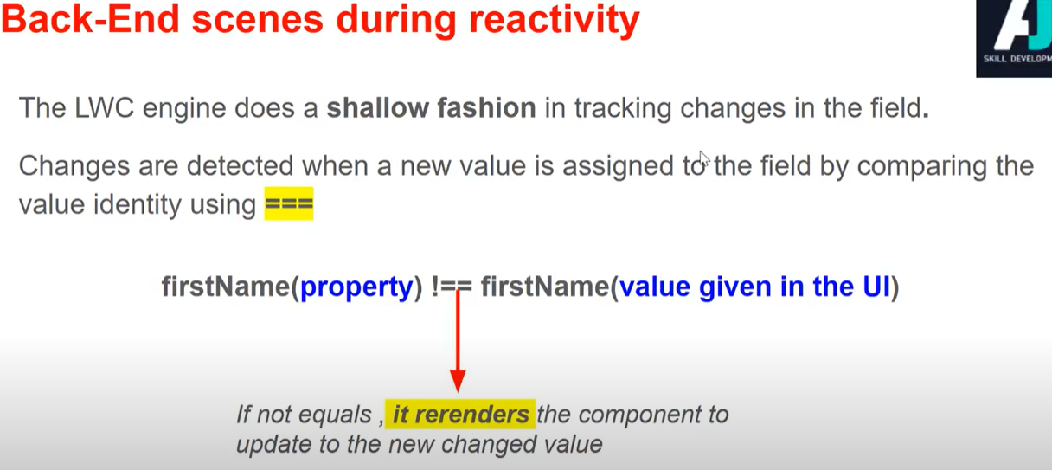

To make a non primitive data type to be reactive:  
use @track annotator:  
Tracked properties are called private reactive property

Conditional rendering:  
Based on JS Property:  
 Boolean property value  
 getter property which returns a Boolean value  
Html:  
 lwc:if  
 lwc:else if  
 else  
Template Looping:  
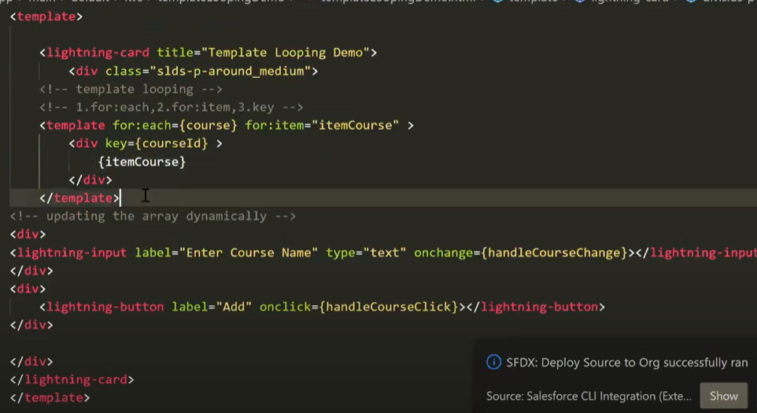  
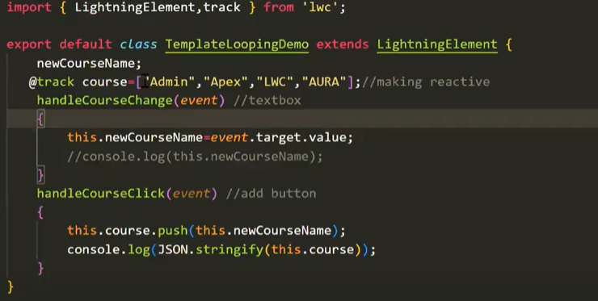  
Use JSON.Stringify to convert proxy into string

for:index-object:  
When the source object array doesn’t have any unique identifier for key we can go for for:index  
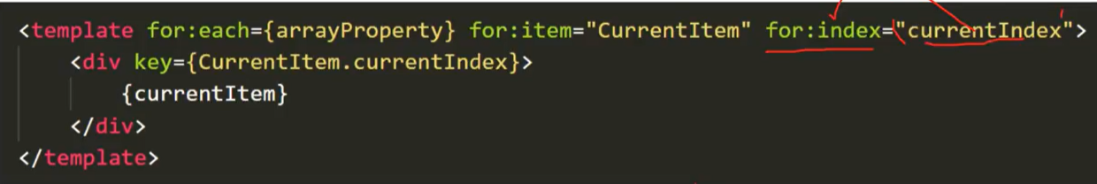  
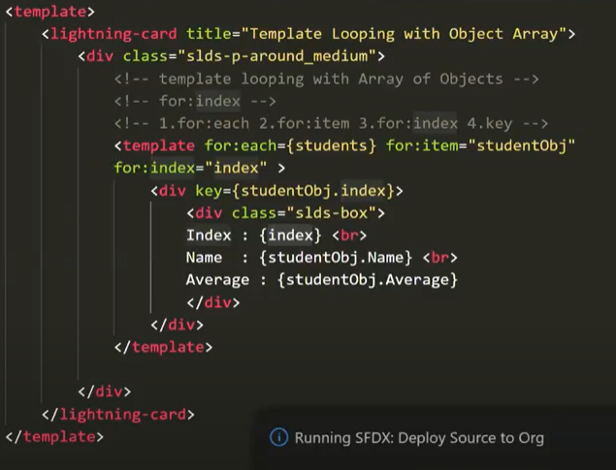

for:index- array:  
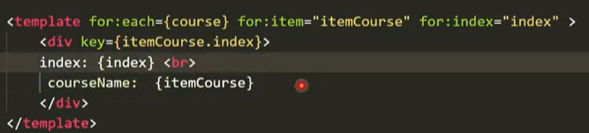

Use bullet list in array:  
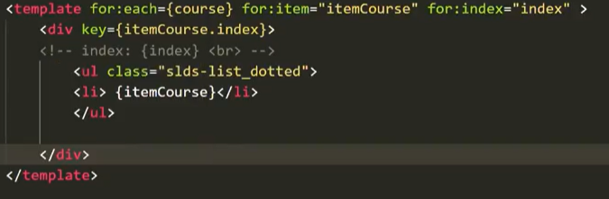  
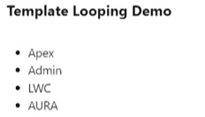  
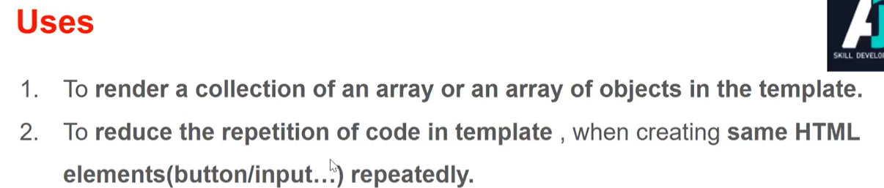

Template Iterator:  
To render a list of items in the template  
To apply a special rendering in the first or last items in a list  
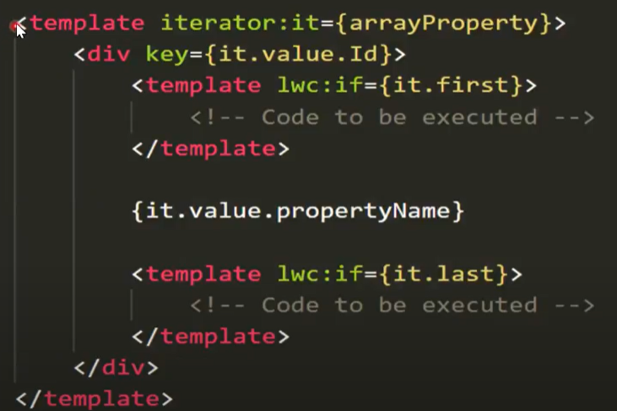  
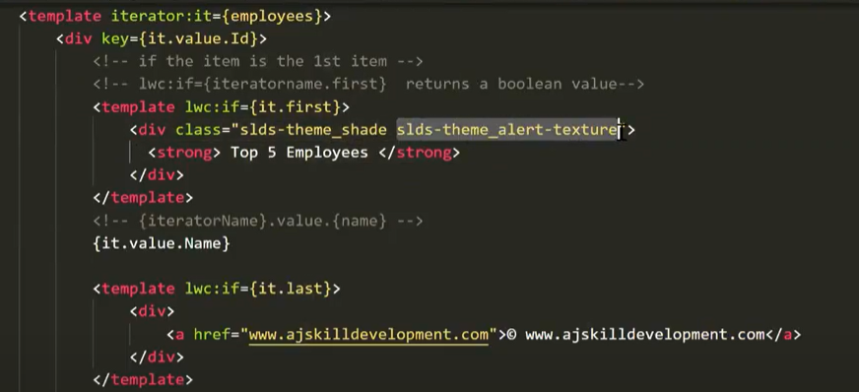  
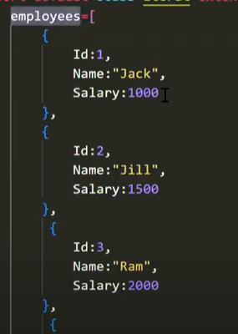

Component Composition:  
In real world creating a single component and dumping all the concepts in a single component is not recommended  
Component Composition means adding a component into body of the another component  
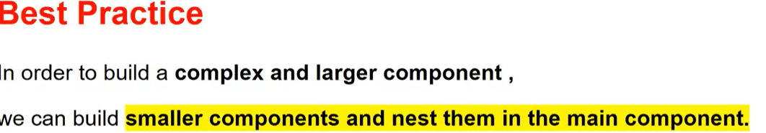  
Parent component – container  
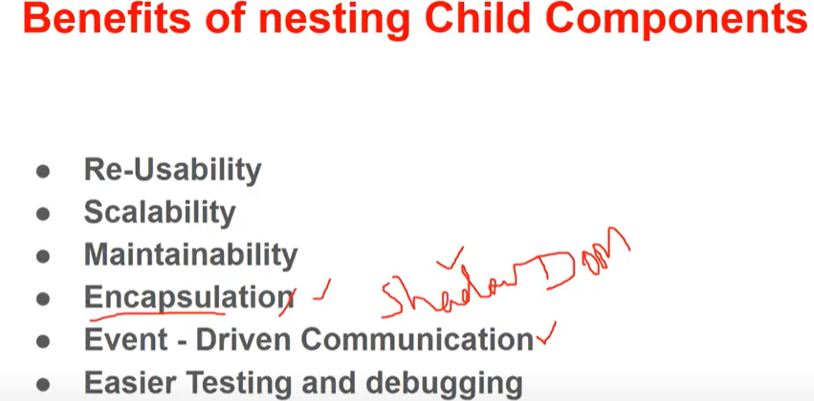

LWC:Ref:  
Spring 23 release  
used to query the DOM elements  
Can be used in parent and child components  
Replaced this with this.template.querySelector()  
**lwc:ref=’uniqueName’(HTML)  
this.refs.refName(JS)**

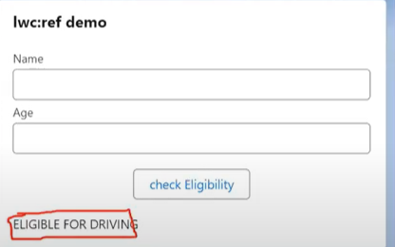  
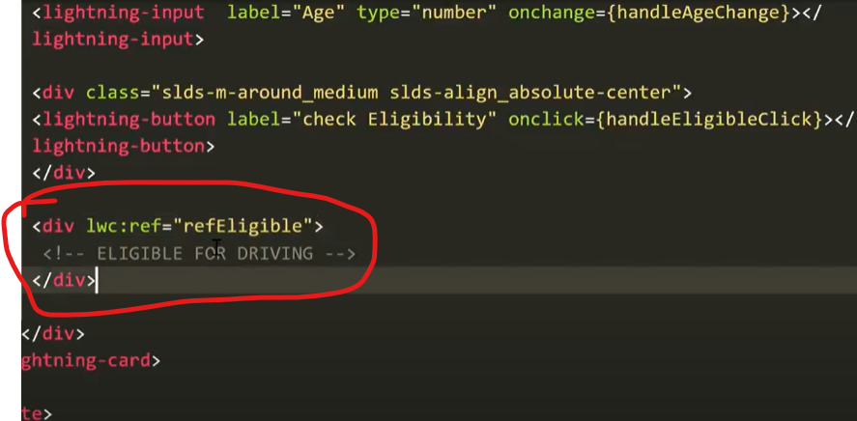  
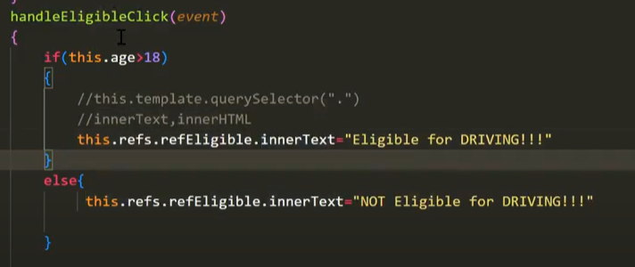

We can insert tags with the help of innerHTML  
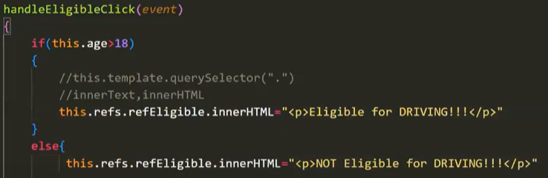  
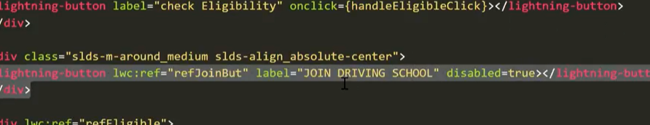

When multiple tags with same ref name:  
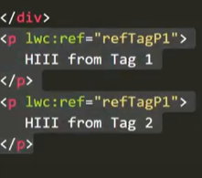

In the JS it returns the last rendered component  
So to overcome that we can go with queryselectorall  
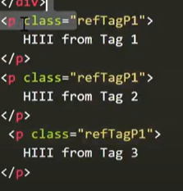  


Parent child communication:  
To pass string data:  
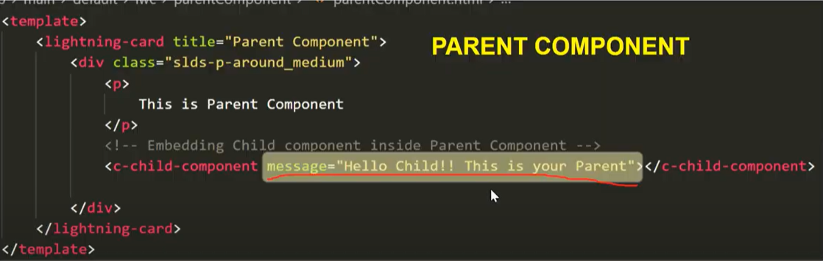  
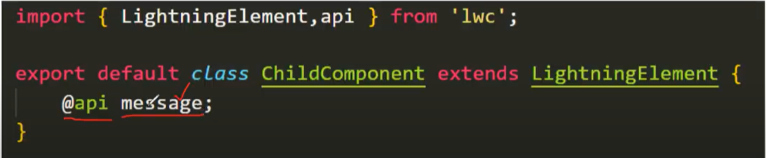  
@api variable-public property and reactive  
To pass arrays and objects:

Setter Method:  
used to do some logic when a value of the property is being set  
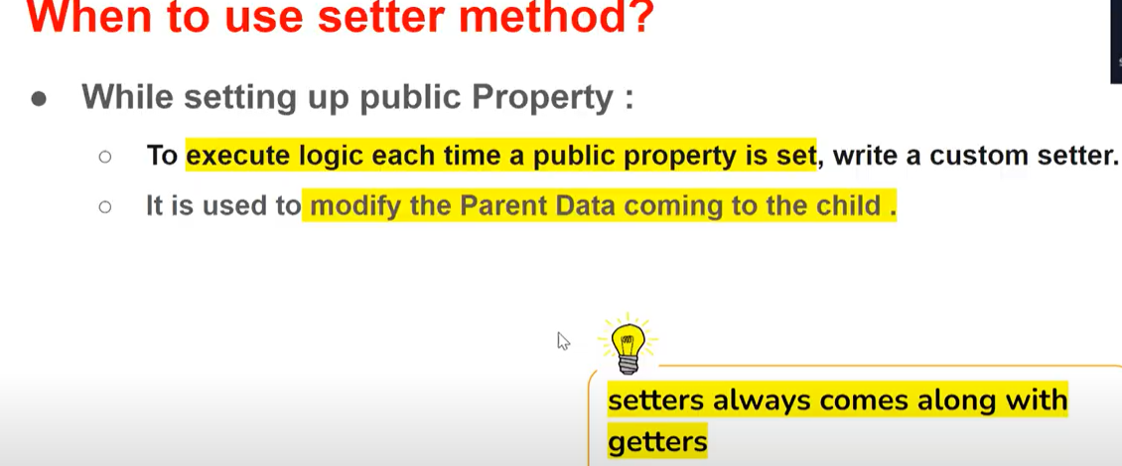  
Set property will execute first before getter  
Setter will be called immediately when a component is mounted  
setter comes along with getter  
best practice:annotate @api in getter in child component  
Naming convention of private property starts with _  
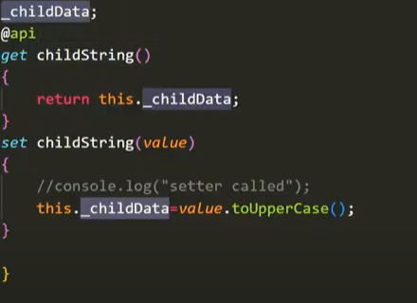  
To convert the proxy into array in the setter – shallow copy using spread operator  
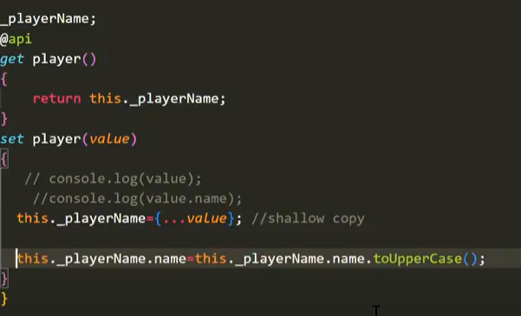  


Shadow DOM:  
DOM:  
JS doesn’t understand the HTML document  
Browser creates a DOM tree like Structure  
DOM is a Document object model – programming interface for web documents  
Data representation of object ,represents the document as nodes and objects which is understandable by JS

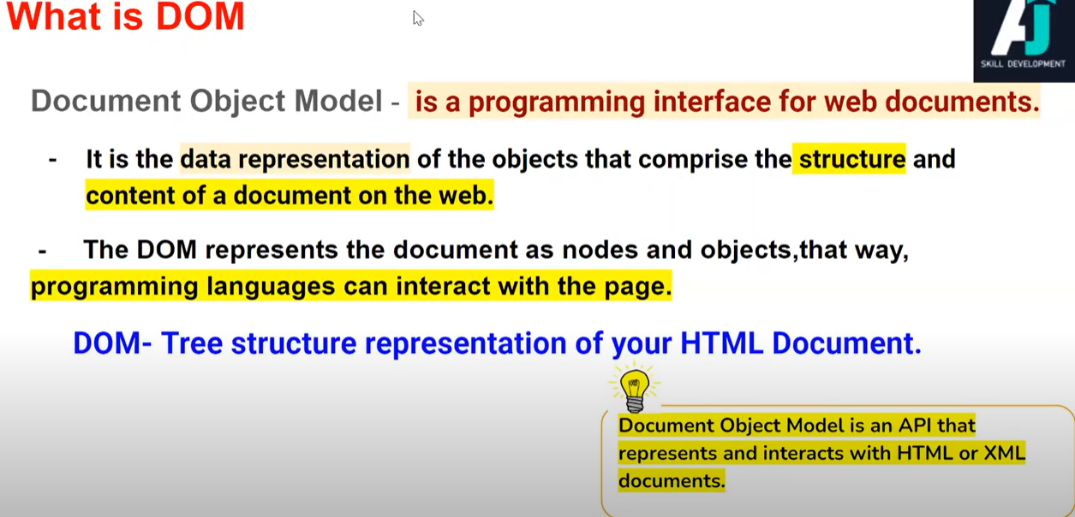  
Refer later

Child to parent communication:  
1.With simple event:  
in a child create a custom event and dispatch the event  
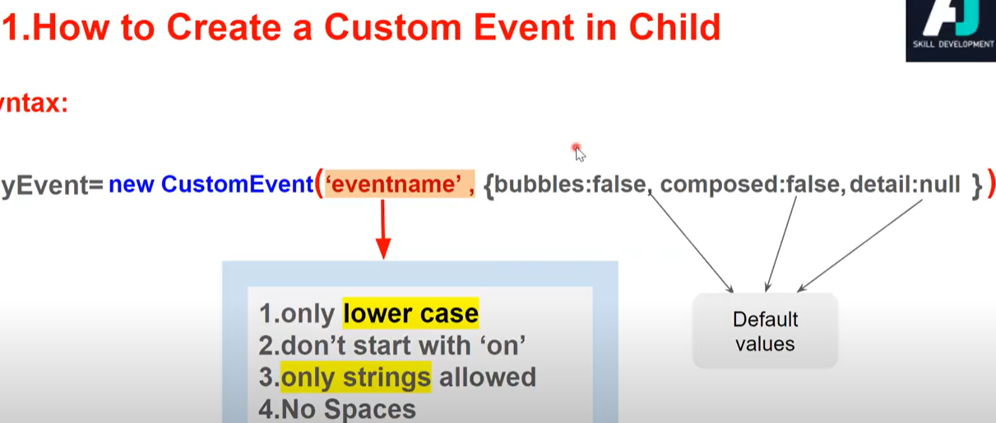  
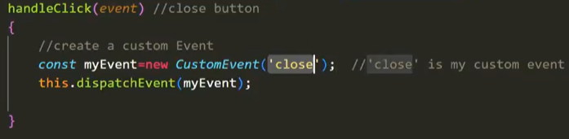  
2.With data  
pass data:  
Simple string  
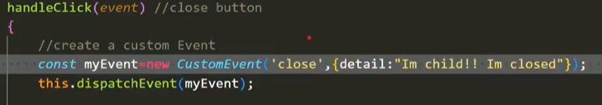  
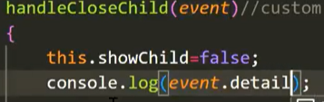  
Passing an array  
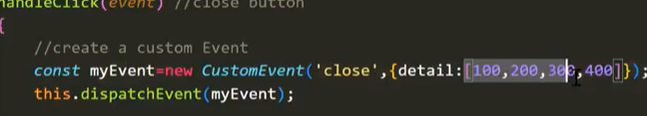  
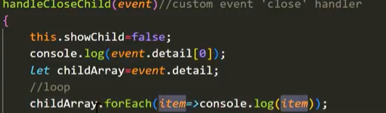  
Passing an object  
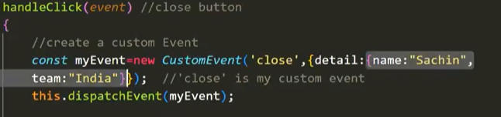  
passing dynamic user child input to parent  
3.Event Bubbling:After event is fired it propagates up through the DOM  
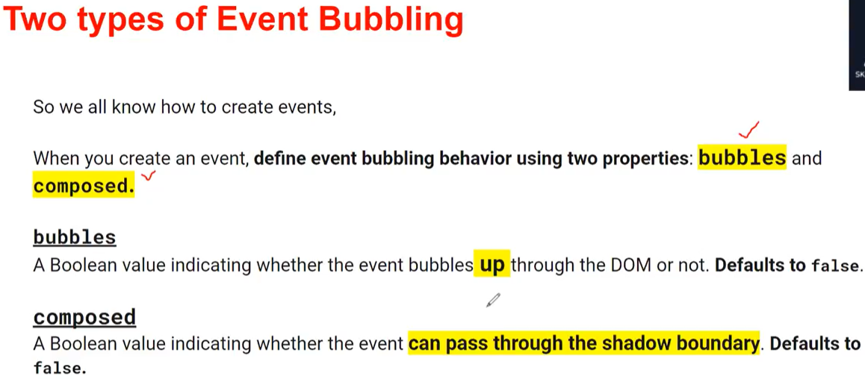  
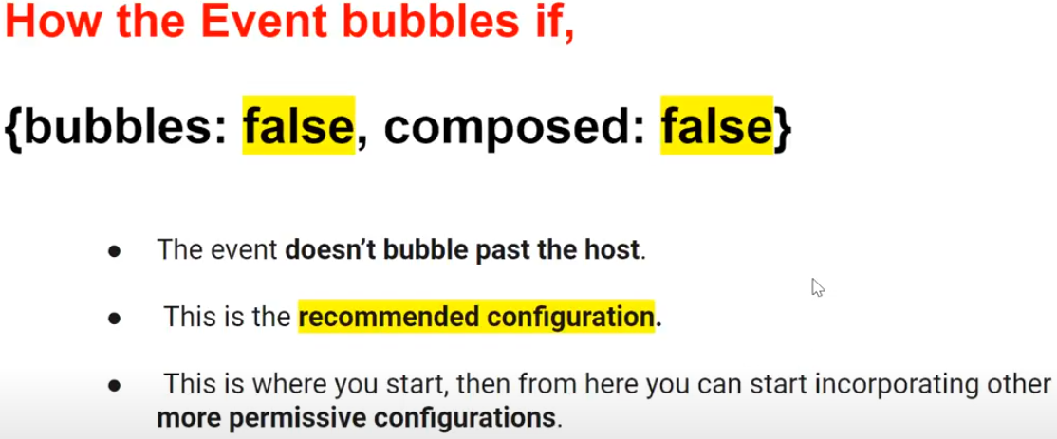  
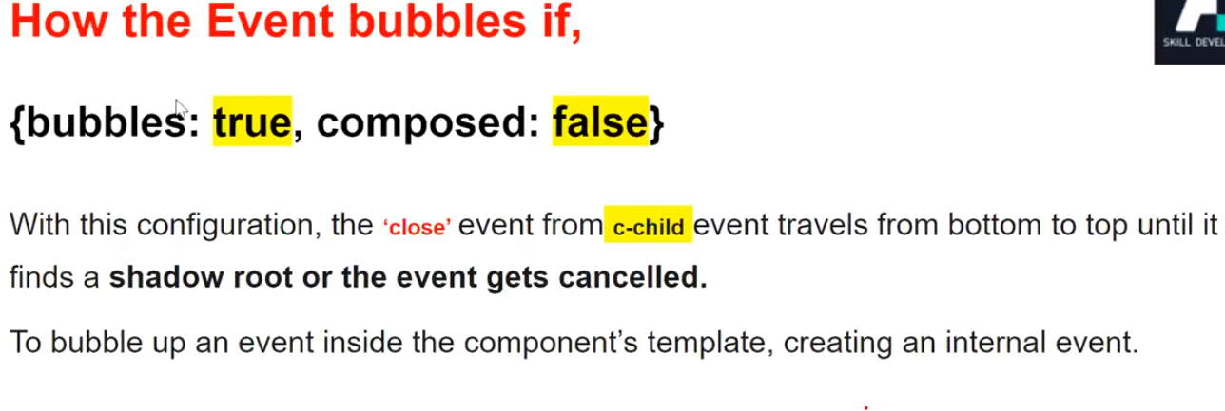  
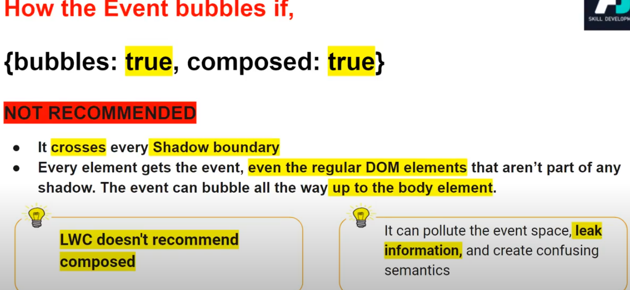

LifeCycle Hooks:  
1.Constructor  
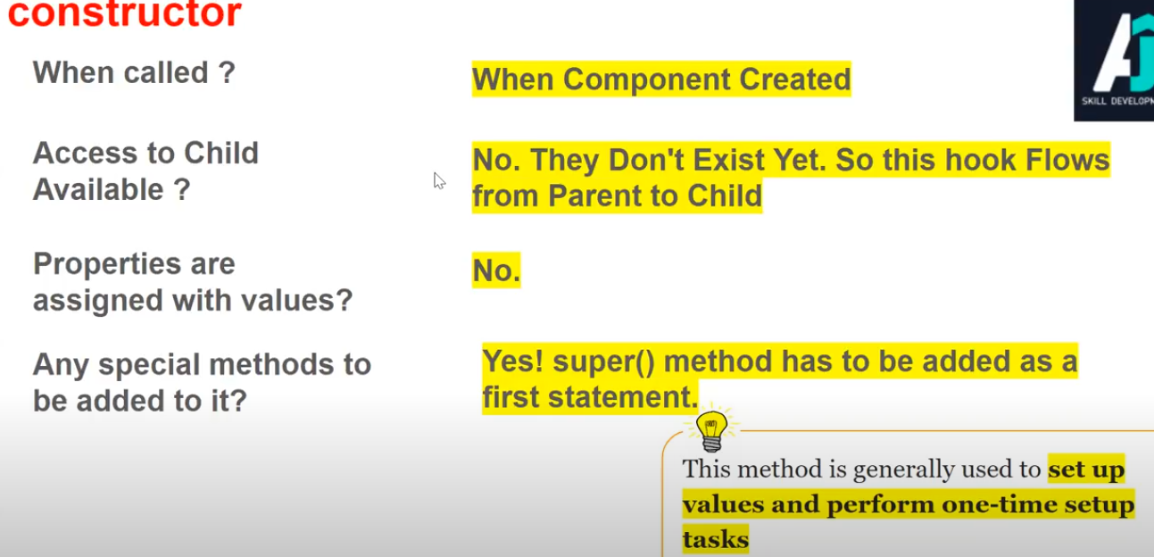

2.Connected Callback:  
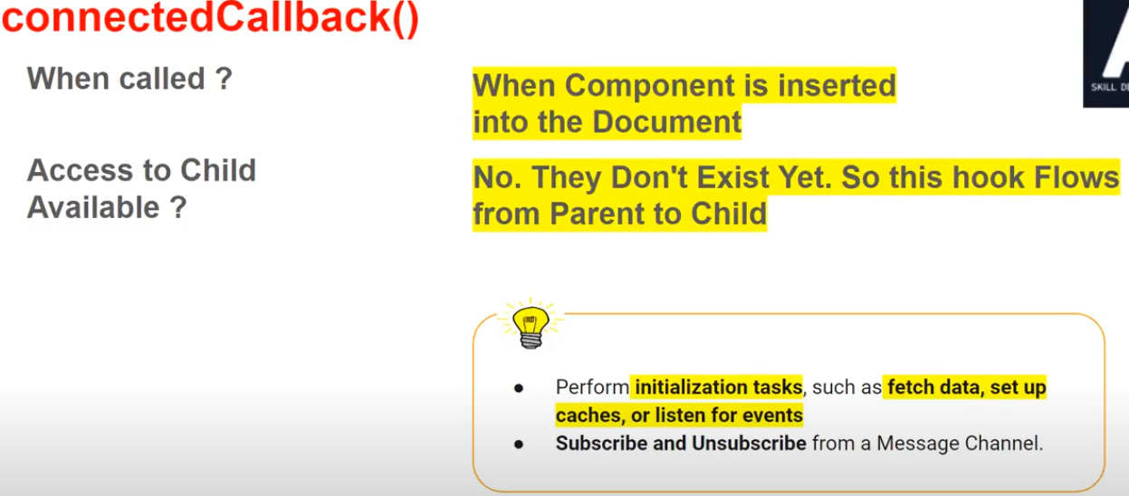  
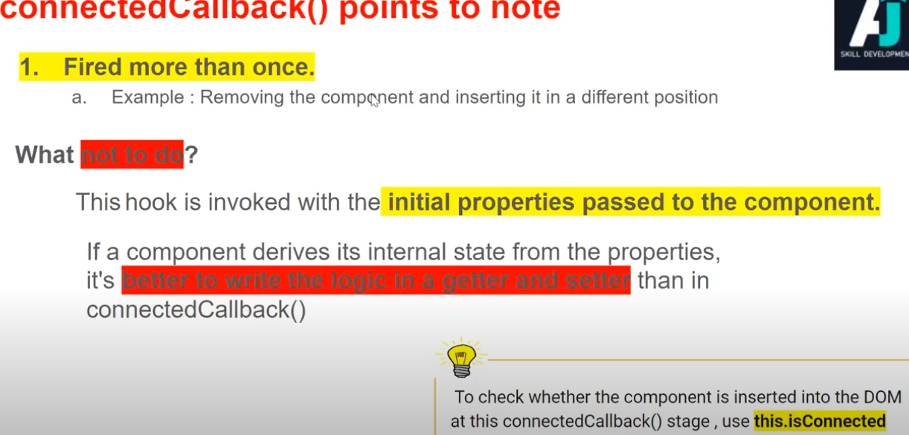

3.Rendered Callback:  
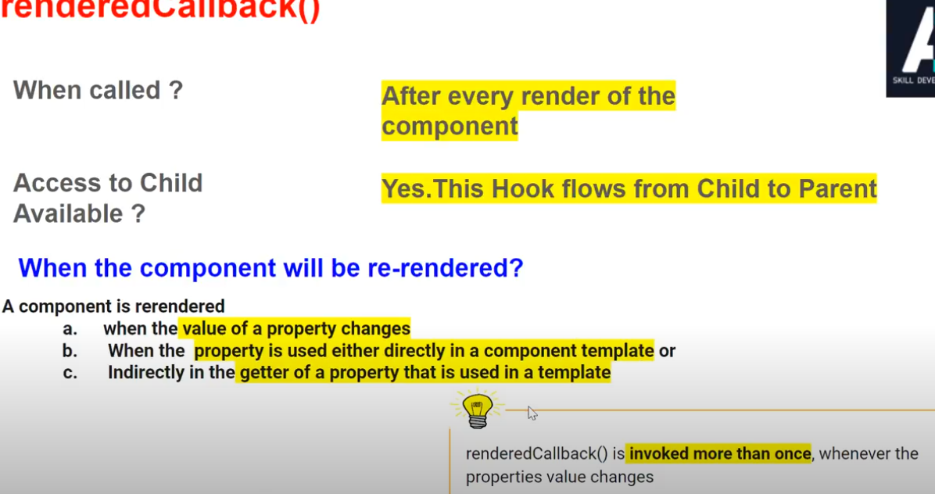  
If we assign a logic or code in the rendered call back want to make the rendered callback to execute only once.see below  
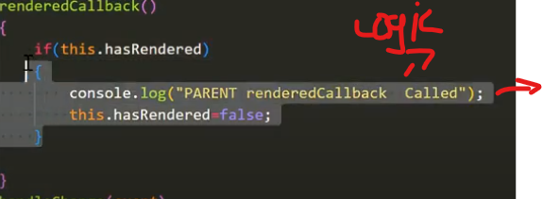  
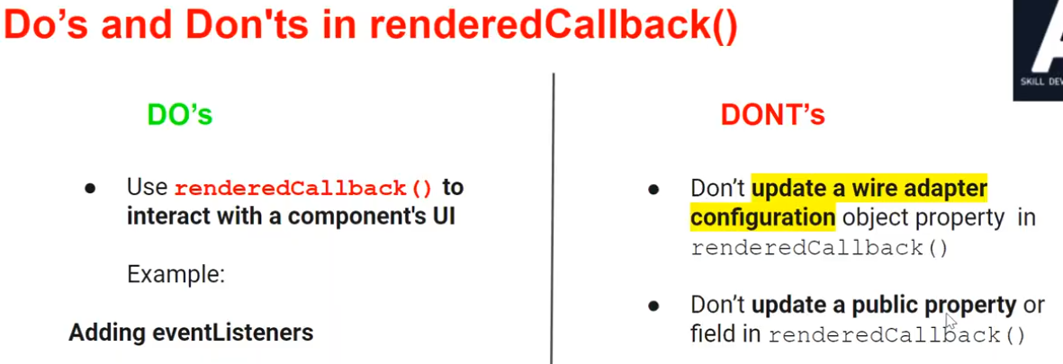

Unmounting Phase:  
disconnected Callback():  
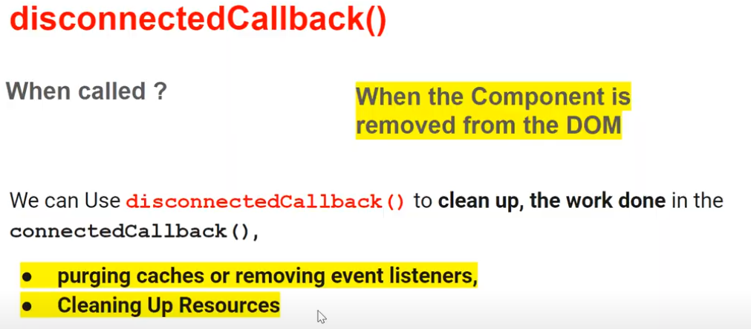

Error Phase:  
error callback():  
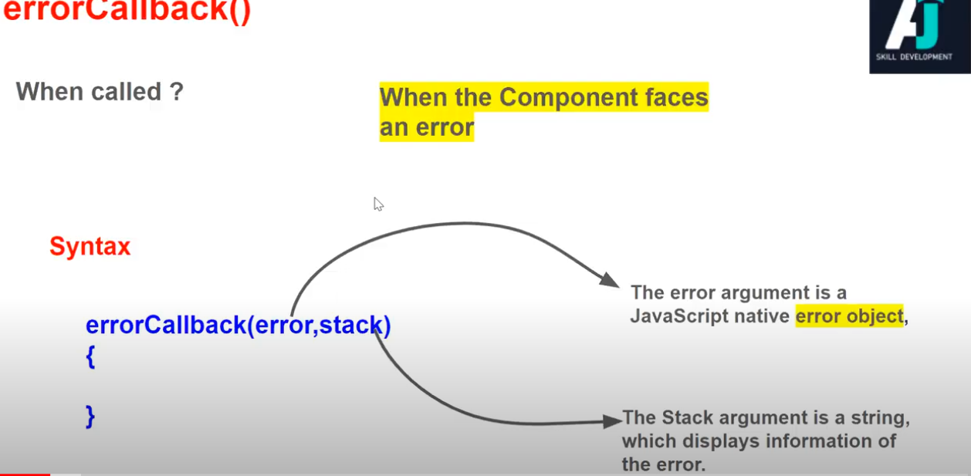  
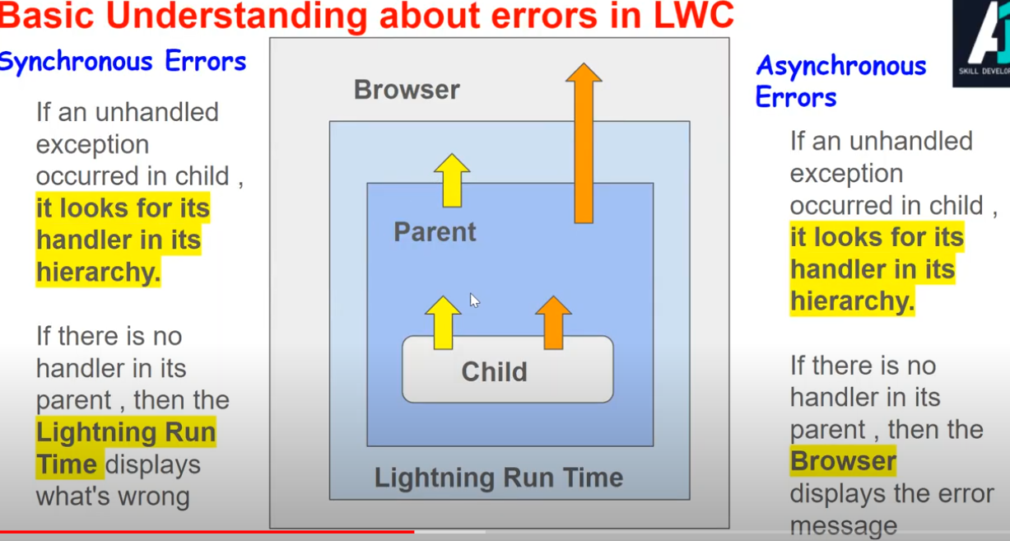  
Create custom error:  
